Chapter 3

Procedure
Description
This chapter discusses the social function, the generic structure, and the linguistic features of a procedure text.
Basic Competence
You will be able to evaluate the genre of a text through its structure and features.
Objectives
After finishing this chapter, you will be able to analyze a procedure text.
Indicators
After finishing this chapter, you will be able to:
- Analyze the social function of a procedure text
- Analyze the generic structure of a procedure text
- Analyze the language features of a procedure text

3.1 What Is Procedure?
Procedure is a text that shows a process in order. Procedure texts are also handy for showing people how to accomplish various tasks. Procedure texts may also be:
- Texts that explain how something works or how to use instruction/operation manuals e.g. how to use the video, the computer, the tape recorder, the photocopier, the fax.
- Texts that instruct how to do a particular activity, for example recipes, rules for games, science experiments, road safety rules, direction, itinerary.
- Texts that deal with human behavior, for example how to live happily, how to succeed.
You encounter procedural texts in most learning areas; in Home Economics (recipes), in Science (experiments), or in Technology (how to….).

3.1.1 Social Function
Procedure describes how something is completely done through a sequence of series.

3.1.2 Generic Structure
The generic structure of a procedure text usually consists of the following elements:
- The goal of the activity
This is where readers know what he/she is going to achieve (e.g. make biscuits, play a computer game, change a tire, do an experiment)
- Any materials, ingredients, or requirements needed for the procedure
These could be ingredients for the biscuits, how to install the computer game, tools to change the tire, equipment for the experiment.
- Steps to achieve the goal
It contains the steps to make the thing stated in the goal. (For example, First, wash the tomatoes, onion,….; Second, cut the onions…). They are written in order and may contain diagrams or pictures.
- Conclusion
You may wish to include a conclusion. That is what can be expected from the procedure. It could include the result of the experiment, a tire safely changed, pleasure from a computer game or well-cooked biscuits of a particular flavor, appearance, and texture.

The following is an example of a procedure text structure.

Title | Julieanne’s recipe for preparing pikelets
The goal of the activity | To make pikelets.  Pikelets are like small pancakes. They are easy to make and good for school lunches or morning or afternoon tea.
What you need | 1 cup self raising flour  ¼ teaspoon bicarbonate of soda  2 tablespoons sugar  1 cup sour milk (to make sour milk add lemon or vinegar)  1 egg
What you have to do | Mix all together in a bowl.  Then, heat fry pan to 340º C.  Oil base of pan (just enough so that the pikelets will not stick).  Next, place 1 tablespoonful of mixture at a time in the fry pan until bubbles form then turn.  When brown on both sides turn out on a plate.
Result  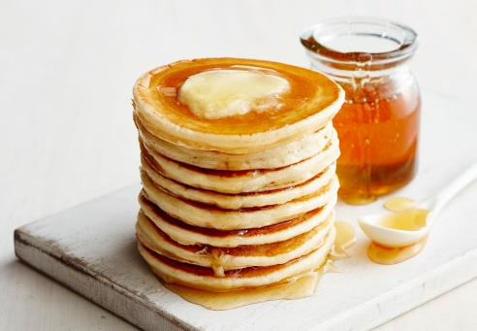 | You should now have pikelets which are attractive in appearance, non-sticky texture and pleasant to taste. Pikelets may be eaten warm or cold.  They may be eaten as is, or with jam or honey.

3.1.3 Language Features
The following list is the common language features of a procedure text:
- Using adverbial of sequence/temporal conjunction (example: first, second, third, the last)
- Using command/imperative sentence (example: put the noodles, cut the onion, wash the tomatoes). Short clear instructions or statements are usually used.
- Using action verbs, such as fold, measure, shake, cut, drill, glue, pour
- Using simple present tense
- May contain adverbs, such as slowly, quickly, carefully, gently, accurately, vigorously, lightly, tightly firmly

Study the language features of the following procedure text.

Title | Julieanne’s recipe for preparing pikelets
Temporal conjunction  Imperative  Action verbs  SIMPLE PRESENT TENSE | To make pikelets.  Pikelets ARE like small pancakes. They ARE easy to make and good for school lunches or morning or afternoon tea.
1 cup self raising flour
¼ teaspoon bicarbonate of soda
2 tablespoons sugar
1 cup sour milk (to make sour milk add lemon or vinegar)
1 egg
Mix all together in a bowl.
THEN, heat fry pan to 340º C.
Oil base of pan (just enough so that the pikelets will not stick).
NEXT, place 1 tablespoonful of mixture at a time in the fry pan until bubbles form then turn.
WHEN brown on both sides turn out on a plate.
You should now have pikelets which ARE attractive in appearance, non-sticky texture and pleasant to taste. Pikelets may be eaten warm or cold.
They may be eaten as is, or with jam or honey.

3.2 Exercise
1. Read and study the text below. Then, answer the following questions.
- What is the social function of the text?
- Which part of text belongs to goal?
- Which part of paragraph belongs to materials?
- What are the steps to score a goal?
- How is the text concluded?
- Find action verbs in the text.
- Find the imperative sentences in the text.
- What kind of tense is mostly used? Give examples.

Scoring a goal at netball

These are some tips if you want to score a goal at netball.

What you need
Practice your skill on a netball court. If not, you may have a netball ring in the backyard at home.

What you have to do
- Hold the ball with your hands. One hand steadies the ball; the other is part of your shooting arm.
- Hold the ball above your head.
- Keep your back straight.
- Feel your feet pointing towards the goal post.
- Aim at a spot just above the goal post - about 15 cms.
- You are ready to shoot: Elbows and knees bend together for the shoot.
- Now elbows and knees are straightened at the same time, and with a flick of your wrist the ball is on its way to score a goal.
- Another option is to aim at the middle part of the goal ring.
But whatever you choose, stick with it. Remember, practice makes perfect.

Result
Once you know the movement you will need to practice it as often as you can.
You will be spurred on, as you score more goals at practice.
Try shooting for goals from more difficult positions.

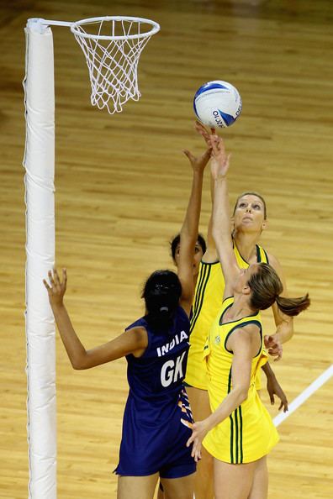

2. Read and study the following text. Then, analyze it in terms of its genre.

How to install Amazon Appstore apps

Amazon has its own appstore with lots of great stuff. The big attraction there is that they make one premium app free every day.

- Visit http://www.amazon.com/getappstore on your Android device's browser (usually Chrome).
- Tap Download the Amazon Appstore. You may get a warning that it's dangerous to download .apk files, but go ahead and download this one by tapping OK in the box that pops up.
- Swipe down from the top of the screen to view the notification tray. When the download completes, tap the icon for the Amazon Appstore .apk download in the notification tray.
- You may be warned that you can't install from unknown sources. If so, tap the Settings button in the pop-up, scroll down to the Device Administration subheading, tap Unknown Sources, and OK in the following warning pop-up. You may need to tap the back button at the bottom of the screen to return to the browser and tap the download button again.
- Tap the Next button in the permissions pop-up that appears after opening the Appstore installation file, then tap Install.
- Tap Open in the pop-up that appears once installation is complete. There will also be an icon on your home screen to tap in order to open the Appstore.
- Enter your Amazon account e-mail address and password by tapping on either box and typing on the pop-up keyboard. If you don't have an Amazon account, tap the Create account button and follow the instructions there.
- Once logged in, browse the featured sections, or tap the menu button in the top-left to drill down into specific categories, or the magnifying glass in the top-right to search for specific apps.

(Taken from https://www.androidcentral.com/android-apps-install)

3.3 Summary
Procedure texts describe how something is completely done through a sequence of series. The generic structure consists of general goal, materials, and steps. A procedure text uses adverbial of sequence/temporal conjunction, command/imperative sentence, action verbs, simple present tense, and may contain adverbs.

