Menu Program
Tampilan Program
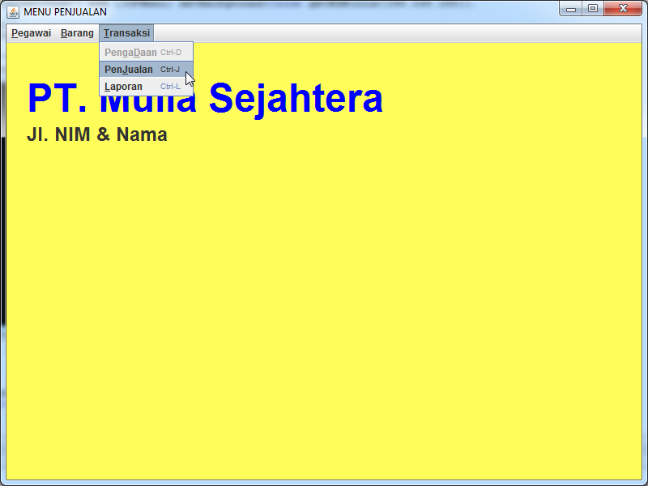

Kode Program

import java.awt.*;
import java.awt.event.*;
import javax.swing.*;
import javax.swing.event.*;
import java.awt.Font;
import java.awt.Color;

// Menu.........................................................................
class FMenuUASNIM extends JFrame {
//============================================================== attribute
private JTextArea m_editArea = new JTextArea(20, 50);
private JPanel JPMenu = new JPanel();

private JPopupMenu m_popup = new JPopupMenu();
private JLabel lNama = new JLabel ("PT. Mulia Sejahtera"),
lAlamat = new JLabel ("Jl. NIM & Nama");
//Nama Ganti dengan Nama dan NIM anda

//========================================================== constructor
public FMenuUASNIM() //2020 ganti dengan 4 digit nim terakhir
{

setPreferredSize(new Dimension(800,600));
setTitle("MENU PENJUALAN");

JDesktopPane JDPMenu = new JDesktopPane();
setDefaultCloseOperation(JFrame.EXIT_ON_CLOSE);
lNama.setBounds (25, 40, 700, 55);
lNama.setFont( new Font( "Dialog" , 1 , 48 ));
lNama.setForeground(Color.BLUE);

lAlamat.setBounds (25, 95, 300, 35);
lAlamat.setFont( new Font( "Dialog" , 1 , 24 ));

//sub menu (M0) Pegawai.....................................
JMenuItem M01Pegawai = new JMenuItem("Pegawai");
M01Pegawai.setMnemonic('P');
M01Pegawai.setAccelerator(KeyStroke.getKeyStroke("control P"));

JMenuItem M02Password = new JMenuItem("PaSsword");
M02Password.setMnemonic('S');
M02Password.setEnabled(false);
M02Password.setAccelerator(KeyStroke.getKeyStroke("control S"));

JMenuItem M03Quit = new JMenuItem("Quit");
M03Quit.setMnemonic('Q');
M03Quit.setAccelerator(KeyStroke.getKeyStroke("control Q"));

//sub menu (M1) Barang.....................................
JMenuItem M11Barang = new JMenuItem("Barang");
M11Barang.setMnemonic('B');
M11Barang.setAccelerator(KeyStroke.getKeyStroke("control B"));

JMenuItem M12Stok = new JMenuItem("Stock Minim");
M12Stok.setMnemonic('M');
M12Stok.setEnabled(false);
M12Stok.setAccelerator(KeyStroke.getKeyStroke("control M"));

//sub menu (M2) Transaksi.....................................
JMenuItem M21Pengadaan = new JMenuItem("PengaDaan");
M21Pengadaan.setMnemonic('D');
M21Pengadaan.setEnabled(false);
M21Pengadaan.setAccelerator(KeyStroke.getKeyStroke("control D"));

JMenuItem M22Penjualan = new JMenuItem("PenJualan");
M22Penjualan.setMnemonic('J');
M22Penjualan.setEnabled(true);
M22Penjualan.setAccelerator(KeyStroke.getKeyStroke("control J"));

JMenuItem M23Laporan = new JMenuItem("Laporan");
M23Laporan.setMnemonic('L');
M23Laporan.setEnabled(true);
M23Laporan.setAccelerator(KeyStroke.getKeyStroke("control L"));

// (2) Build menubar, menus, and add menuitems.
JMenuBar menubar = new JMenuBar(); // Create new menu bar
JMenu MenuPegawai = new JMenu("Pegawai"); // Create new menu
MenuPegawai.setMnemonic('P');
menubar.add(MenuPegawai);
MenuPegawai.add(M01Pegawai);
MenuPegawai.add(M02Password);
MenuPegawai.addSeparator();
MenuPegawai.add(M03Quit);
JMenu MenuBarang = new JMenu("Barang");
MenuBarang.setMnemonic('B');
menubar.add(MenuBarang);
MenuBarang.add(M11Barang);
MenuBarang.add(M12Stok);
JMenu MenuTransaksi = new JMenu("Transaksi");
MenuTransaksi.setMnemonic('T');
menubar.add(MenuTransaksi);
MenuTransaksi.add(M21Pengadaan);
MenuTransaksi.add(M22Penjualan);
MenuTransaksi.add(M23Laporan);

//Siap untuk menjalankan pilihan...............................
M01Pegawai.addActionListener(new BukaPegawai());
M03Quit.addActionListener(new QuitAction());
M11Barang.addActionListener(new OpenAction());
M22Penjualan.addActionListener(new BukaJual());
M23Laporan.addActionListener(new Laporan());

//... Add the (unused) text area to the content pane.
JPanel content = new JPanel();
content.setLayout(new BorderLayout());
content.add(m_editArea, BorderLayout.CENTER);

//... Add menu items to popup menu, add popup menu to text area.
m_popup.add(new JMenuItem("Testing"));
m_editArea.setComponentPopupMenu(m_popup);

//... Set the JFrame's content pane and menu bar.
setContentPane(content);
setJMenuBar(menubar);

JDPMenu.add (lNama);
JDPMenu.add (lAlamat);
getContentPane().add (JDPMenu).setBackground(Color.getHSBColor(180,100,200));

pack();
setLocationRelativeTo(null);
}

class OpenAction implements ActionListener {
public void actionPerformed(ActionEvent e) {
JOptionPane.showMessageDialog(FMenuUASNIM.this, "Can't Open.");
}
}

//buka Form Pegawai.........................................................
class BukaPegawai implements ActionListener {
public void actionPerformed(ActionEvent e) {

FBarangNIMNama xBarangNIMNama = new FBarangNIMNama();
xBarangNIMNama.setVisible(true);

// FPegawai xPegawai = new FPegawai();
// xPegawai.setVisible(true);

//..........................................
//panggil Form pegawai untuk menjalankan program pegawai !
//Perintah System.exit(0); pada FPegawai ganti dengan perintah
// this.dispose();
// System.exit(0); menjadi this.dispose();
}
}

//Buka FormBarang.......................................................
//hapus double slashnya "//"............................................
class BukaBarang implements ActionListener {
public void actionPerformed(ActionEvent e) {
//FBarang xBarang = new FBarang();
//xBarang.setVisible(true);
}
}

class BukaJual implements ActionListener {
public void actionPerformed(ActionEvent e) {
//FJual xJual = new FJual();
//xJual.setVisible(true);
}
}

class Laporan implements ActionListener {
public void actionPerformed(ActionEvent e) {
//CetakBrg xLaporan = new CetakBrg();
//xLaporan.setVisible(true);
}
}

class QuitAction implements ActionListener {
public void actionPerformed(ActionEvent e) {
System.exit(0); // Terminate the program.
}
}

// main progrm............................................................
public static void main(String[] args) {
JFrame win = new FMenuUASNIM();
win.setVisible(true);
}
}

