SOAL QUALIFICATION

PRE-TEST MYOB BASIC
Mr. Tjandra is the owner of Company “SILVER, PT”. His Business as Car Dealer buys new cars and used cars and sells them to end users, since December 2017.
Mr. Tjandra starts using MYOB Accounting 23 software for his company “SILVER, PT”to prepare his 1 Jan 2018 to 31 Dec 2018 Financial Year Reports. And prefer to have 13th accounting period, so he can use the 13th month for recording any tax adjustment.
You are required to:
- Setup the company data file according to the fact given. Save it in Your Folder Name and name the Company Data File Name as Company Name, your name.
  - Company Name :
  - Current Financial Year :
  - Last Month of Financial Year :
  - Conversion Month :
  - Number of Accounting Periods :

- a. Setup the Accounts List from the list provided by MYOB Accounting Software : Business Type: Car Dealership
- Delete the following account codes:
  - 1-2120 Payroll Cheque Account
  - 1-2130 Cash Drawer
  - 1-2350 Lease Vehicles
- Edit the following account code:
  - 1-2160 Undeposited Funds, change to: Undeposited Cash

- a. Add Address: INDONESIA into Company Information.
- Setup the Preferences:
  - System Preferences: Tick the option for “Warn if Jobs are not Assigned to All Transactions”.
  - Windows: Non Aktifkan Sistem pengecekan penulisan kata bahasa Inggris otomatis “Automatically check spelling”
- Reports & Forms: Aktifkan pilihan Always Report Customisation Options Before Printing Reports
- Sales: Nonaktifkan pilihan Show Customer Purchase Number in Receive Payments
  - Aktifkan pilihan Warn for Duplicate : Invoice and Customer PO Number on Recorded Sales
    - Klik Terms :Tax Code: N-T, Freight Tax Code: N-T
    - Klik OK
  - Security Preferences: Untick the option for “Prompt for Session Report When Closing & Tick the option for “Check Data File for Errors before the Backup Process”.

- The following transactions are made in 1 Jan 2018. Record these transactions in MYOB according to the dates and details given below.
  - “SILVER, PT”. 1 Jan 2018 Balance Sheet Information
Account Name | Debit | Credit
Mach/Shop Equip at cost | 5,000.00
Mach/Shop Accum Deprec |  | 10.00
Furniture & Fixtures at cost | 3,000.00
Furniture & Fixture Accum Dep |  | 5.00
Cheque Account | 100,000.00
Petty Cash | 100,000.00
Trade Debtors | 15,000.00
New Cars & Trucks | 223,500.00
Used Cars & Trucks | 27,000.00
Trade Creditors |  | 134,000.00
VAT/GST Collected |  | 1,363.64
VAT/GST Paid | 12,181.82
Owner’s/Sharehldr Capital |  | 300,000.00
Retained Earning |  | 50,303.18
Total | 485,681.82 | 485,681.82
  - Tax codes: VAT = 10%,
Job: NC for New Car, UC for Used Car, X for Car Services Category: SM for Semarang, YK for Yogyakarta.
- a. A/R Opening Balances as 31 Dec 2017:
- ANGKASA, PT. = $8,000.- inc. VAT [Category: YK],
- KARYA, CV. = $7,000.- inc. VAT [Category: SM].
- A/P Opening Balances as 31 Dec 2017:
  - HONDA, PT = $66,500.- inc. VAT [Category: SM],
  - TOYOTA, PT = $67,500.- inc. VAT [Category: YK].
- Inventory Opening Balance as 1 Jan 2018: New Cars (Item List)
  - Honda New Accord (Item no. HAC, selling price $21,500.- N-T) = 3 unit for $20,500.-/unit.
  - Honda New CRV (Item no. HCR, selling price $26,000.- N-T) = 3 unit for $25,000.-/unit.
  - Toyota New Krista (Item no. TKR, selling price $16,000.- N-T) = 3 unit for $15,000.-/unit.
  - Toyota New Inova (Item no. TKI, selling price $15,000.- N-T) = 3 unit for $14,000.-/unit

Used Cars (Item List) :
  - Honda Accord - Second hand (Item no. HAS, selling price
$16,000.- N-T) = 1 unit for $15,000.-/unit
  - Toyota Krista - Second Hand (Item no. TKS, selling price
$13,000.- N-T) = 1 unit for $12,000.-/unit. [Category: YK].
- On 2 Jan 2018: Purchase the following inventory item from supplier, HONDA, PT, with Net 20th after EOM credit terms. Supplier will give discount: 2% if Company pays before discount date: 5th. (PO#: P- 800001, Supplier Inv#: HND-800001)
  - Order 5 unit Honda New Accord (HAC) for $20,500.-/unit (Exclude 10% VAT) each. Company was received only 4 unit of total order.
  - Order 3 unit Honda New CRV (HCR) for $25,000.-/unit (Exclude 10% VAT) each. All the order was received. [Category: SM]
7. On 3 Jan 2018:
- Raised Purchase order from supplier, TOYOTA, PT, for 2 unit Toyota Krista (TKR) @$16,500.-/unit (Include 10% VAT) on net 25th credit terms. The car and bill was received (PO#: P-800002, Supplier Inv#: TYT-800001). [Category: YK]
- Raised Purchase order from supplier, TOYOTA, PT, for 2 unit Toyota Krista - Second Hand (TKS) @$13,200.-/unit (Include 10% VAT) on net 25 credit terms (PO#: P-800003, Supplier Inv#: TYT-800002). The car and Bill was received. [Category: YK]
- On 4 Jan 2018: Paid partially to TOYOTA, PT, for total $15,000.-, for Bill on: 31 Dec 2007 ($10,000.-) and 3 Jan 2008 ($5,000.-) using Cheque Account. (NB: Bill on 3 Jan, Paid for Supplier Inv#: TYT-800001).
- On 5 Jan 2018: Received $150.- purchase rebate from HONDA,PT (PO#: P-800001, Supplier Inv#: HND-800001). Immediately applied the $150.- rebate amount as Discount Taken to Trade Creditor balance for HONDA,PT, as purchase rebate for bill on 2 Jan 2008 transaction. [Job: NC] [Category: SM]
- On 6 Jan 2018: Sold 3 unit of Honda New Accord (HAC) @$21,500.- (Exclude 10% VAT) each to ANGKASA, PT, on net 28th after EOM terms (Inv#: S-800001). [Job: NC] [Category: YK] [Salesperson: Rosa]
- On 7 Jan 2018: Charge for Car Service Contract for $110.- (include 10% VAT) to KARYA, CV, on cash term (Inv#: S-800002). [Job: X] [Category: SM] [Salesperson: Joni]
- On 8 Jan 2018: Full payment of $110.- for car service was received from KARYA, CV, and deposit to Petty cash.
- On 9 Jan 2018: Return 1 unit Honda New Accord (HAC) @$21,500.- (Exclude 10% VAT) from customer, ANGKASA, PT (Inv#: S-800001). Immediately applied the Credit Note to Trade Debtor balance for ANGKASA, PT for invoice on 6 Jan 2008 transaction. [Category: YK] [Salesperson: Rosa]
- On 10 Jan 2018: Issued $10.- sales rebate to KARYA, CV, as Car Service Contract (Inv#: S-800002). Immediately pay refund for $10.- Car Service Rebate to KARYA, CV, from Petty cash. [Job: X] [Category: SM] [Salesperson: Joni]

- On 11 Jan 2018: Use spend money, Transfer $400.- to Cheque Account from Petty Cash ($410.-), and pay $10.- as Bank Charges. [Category: YK]

- On 12 Jan 2018: Received $10.80 as Bank Interest Income with $0.80 Bank Charges on Cheque Account, [Category: YK]

- On 31 Jan 2018: Perform Bank Reconciliation for Cheque Account. Bank Statement Balance is $85,410.

- On 31 Jan 2018: Prepare a Journal entry to record:
  - Mach/Shop Equipment Depreciation at $10.- [Category: YK] Save as Monthly Recurring Transactions. Use the recurring and record depreciation journal for 28 Feb 2008.
  - Furniture & Fixtures Depreciation at $5.- [Category: YK] Save as Annually Recurring.

- On 31 Jan 2018: Build Item for Inventory Exchange: for 2 Unit of Toyota Krista - Second Hand (TKS) @$12,500.- with 1 Unit Honda New CRV (HCR) @$25,000.-. [Category: YK]

- On 31 Jan 2018: Sent to PDF the financial Reports for period of January (1 Jan to 31 Jan 2008). Save the reports in Reports Folder.
  - Trial Balance,
  - Recurring Transactions,
  - Card List Summary,
  - Analyze Inventory Summary,
  - Item List Summary,
  - Account Transaction (Accrual) and
  - VAT (Detail-Accrual)

- BACKUP your MYOB Company data file (ONLY), Check Company File for Error and Save the MYOB company data backup file name as Your Name in Backup Folder. From Security Preference, active the option for “Use Audit Trail Tracking”, then Lock the Accounting period for Jan 2018.

- Edit payment to TOYOTA, PT on 4 Jan 2018 to: Pay total $15,000 from Petty Cash, pay for Bill on 31 Dec 2017 ($7,500.-) and Bill on 3 Jan 2017 ($7,500.-). Keep the Cheque or Voucher No. record as No. 1. (NB: Bill on 3 Jan, Paid for Supplier Inv#: TYT-800001)

Comment :

- From Company Data Auditor – Transaction Review for 1 Jan 2018 to 31
Jan 2018, there is a “?” mark for Scan for Futures Dated Transactions. Display & Sent to PDF: The Future Dated Transactions Report.

- Edit the value of Mach/Shop Equipment Depreciation for Journal Entry on 28 Feb 2018 to $15.- and edit the Recurring Transaction Template of Mach/Shop Equipment Depreciation to $15.- per month.

- Display & Sent Report to: Tab Delimited Text File Format the financial Reports for period of January (1 Jan to 31 Jan 2018).

Save the reports in Reports Folder.
  - Std. Balance Sheet,
  - Profit & Loss (Accrual)
  - Jobs P&L
  - Category P&L
  - G/Ledger (Summary
  - Account Transaction (Accrual)
  - VAT (Detail-Accrual)

Note:
- Minus 4 points if:
Wrong Date, Qty, Amount and Accounts.

- Minus 1 points if:
Wrong Terms, Job, Category, Memo, Less 1 Report

You’re Comments (if any):
Folder No :

Full Name :

Place, Date Of Birth :

Email :

School/College :

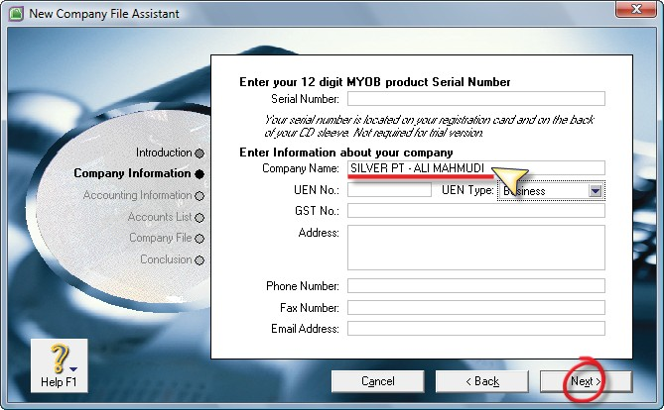
Penyelesaian Ujian MYOB Level Basic

Membuat File Baru

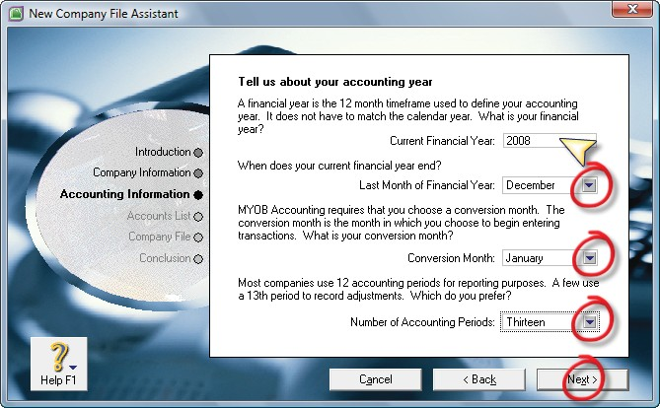
- Buka Program MYOB Accounting 18+
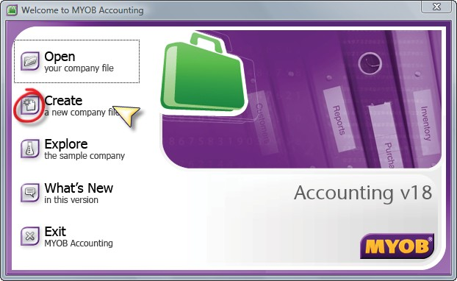
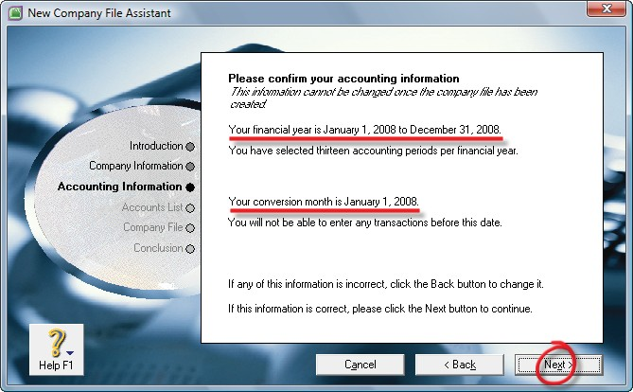
- Pilih dan klik Create a new company file
- Muncul jendela Introduction. Klik Next>
- Company Information :
  - Company Name : ketik nama perusahaan diikuti dengan nama anda masing-masing.
  - Tekan tombol Next
- Accounting Information
  - Current Financial Year : 2018
  - Last Month of Financial Year : December
  - Convertion Month : January
  - Number of Accounting Periods : Thirteen

  - Klik Next>
- Please confirm your accounting information
  - Klik Next>
- Please confirm your accounting information
  - Klik Next>

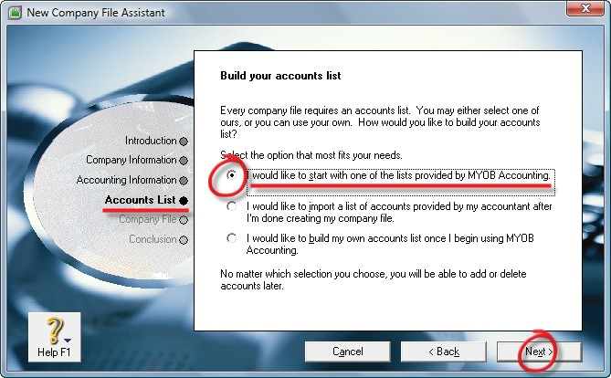
- Account List
  - Pilih I would like to start with one of the lists provided by MYOB Accounting (pilihan pertama)
  - Klik Next>
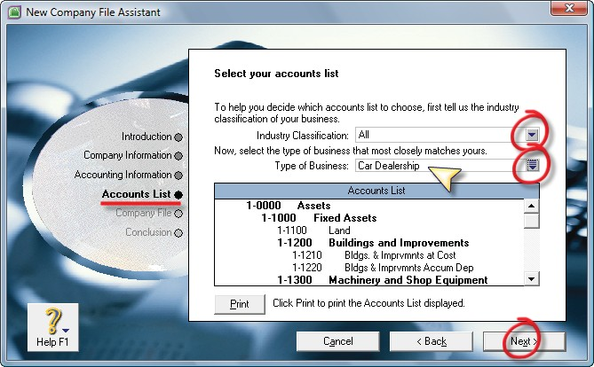
- Select yout accounts list
  - Industry Classification : All
  - Type of Business : Card Dealership
  - Klik Next
- Create your company File
  - Klik tombol Change
  - Akan ditampilkan Windows explorer
- Klik pilihan Desktop
- Klik New Folder
- Ketikkan nama Folder : TEST – NAMA MASING-2
- Klik Open
- File Name : SILVER PT – NAMA MASING-2
- Klik Save
- Klik Next>
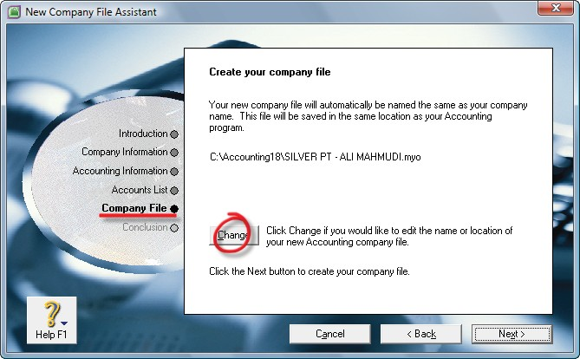

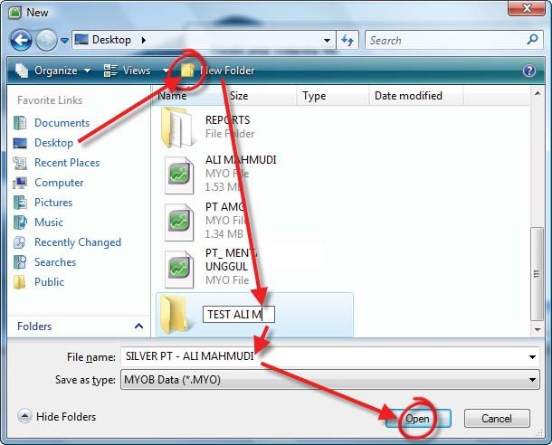

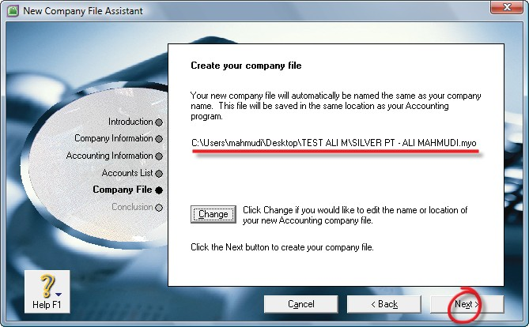
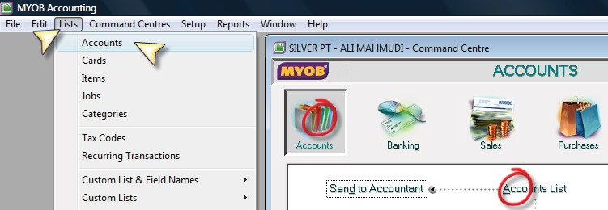

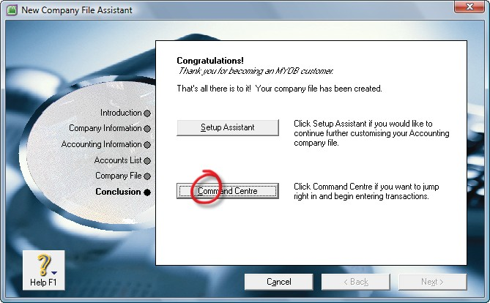
- Conclusion : Klik Command Centre

Menghapus Accounts

- Klik menu Lists – Accounts
- Atau dari menu Command Centre – Accounts – Account Lists
- Pilih Bagian Assets
- Klik anak panah akun 1-2120
- Setelah terbuka daftar akun tersebut, klik menu Edit (kiri atas)
- Klik pilihan Delete Accounts
- Lanjutkan untuk menghapus akun nomor 2-2130 dan 1-2350

Mengganti Accounts
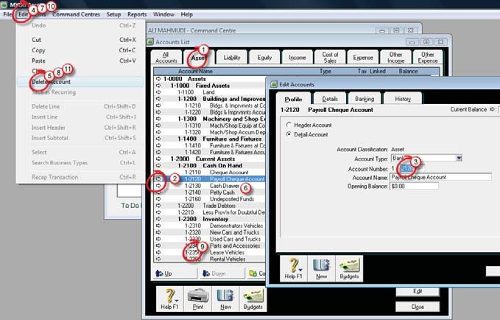
- Masih di tampilan Accounts List
- Double klik akun 1-2160 (Undeposited Funds
- Lalu ganti namanya menjadi Undeposited Cash.

Menambahkan informasi Alamat Perusahaan
- Setup – Company Information
- Tambahkan alamat : INDONESIA
- Klik OK.

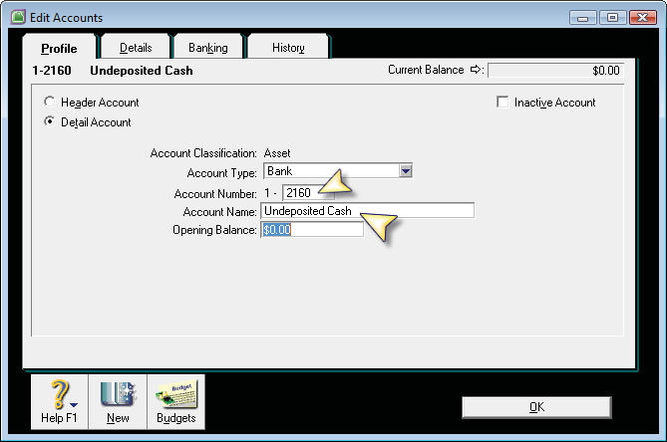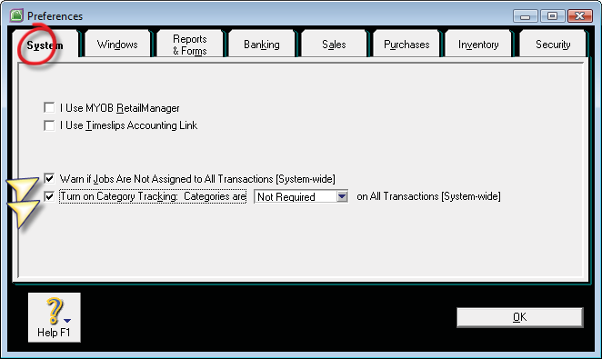

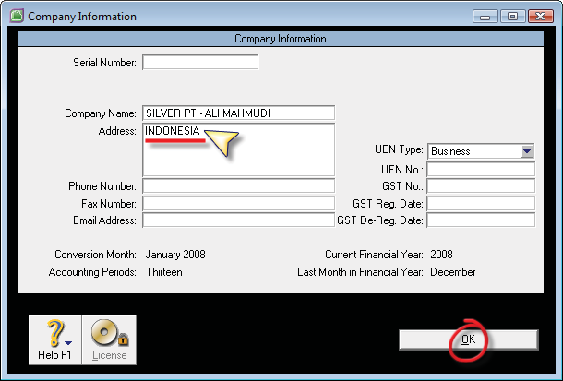
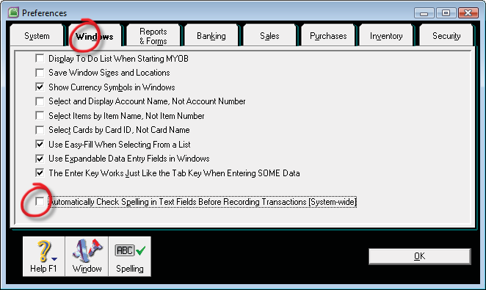
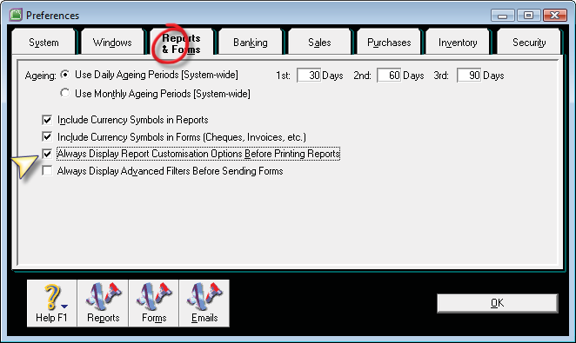
Menentukan Preferences Sistem MYOB

- Buka menu Setup – Preferences
- System
  - Aktifkan pilihan Warn if Jobs Are Not Assigned to All Transaction [System-wide]
- Windows
  - Non aktifkan pilihan Automatically Check Spelling in Text Fields Before Recording Transactions [System-wide]
- Reports & Forms
  - Aktifkan pilihan Always Report Customisation Options Before Printing Reports

- Sales
  - Nonaktifkan pilihan Show Customer Purchase Number in Receive Payments
  - Aktifkan pilihan Warn for Duplicate : Invoice and Customer PO Number on Recorded Sales
  - Klik Terms
    - Tax Code : N-T
    - Freight Tax Code : N-T
    - Klik OK
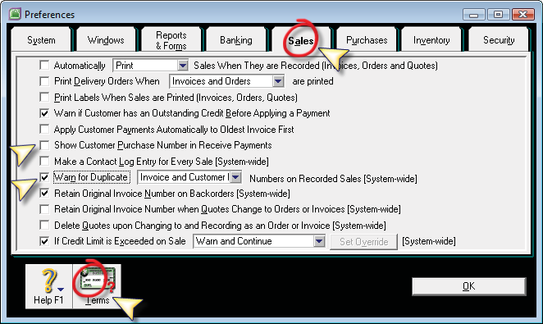

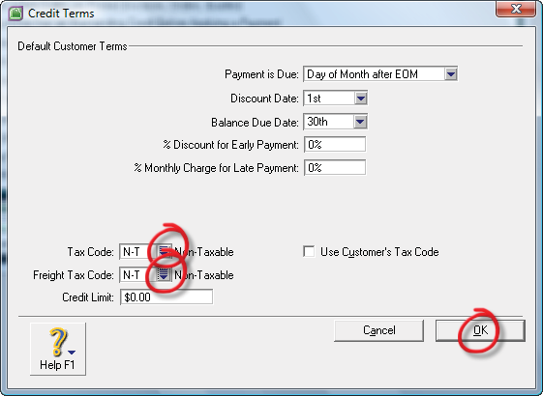
- Purchases
  - Nonaktifkan pilihan Show Supplier Invoice Number in Supplier Payments
  - Aktifkan pilihan Warn for Duplicate : PO and Supplier Invoice Number on Recorded Purchases

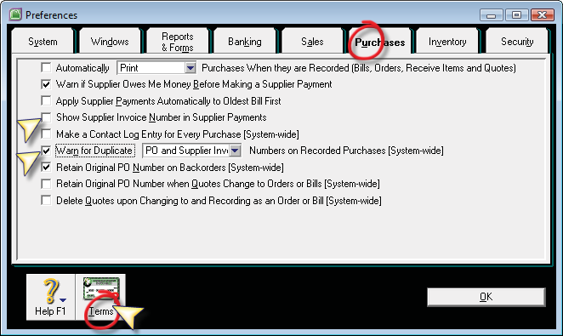
  - Klik Terms
    - Tax Code : N-T
    - Freight Tax Code : N-T
    - Klik OK
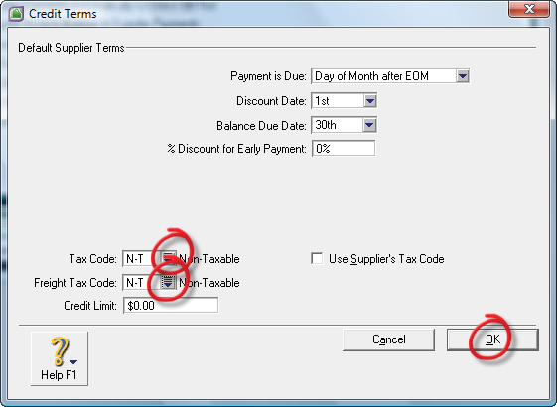
- Security
  - Aktifkan pilihan Prompt for Session Report When Closing
  - Aktifkan pilihan Check Company File for Errors before the Backup Process
  - Klik OK.

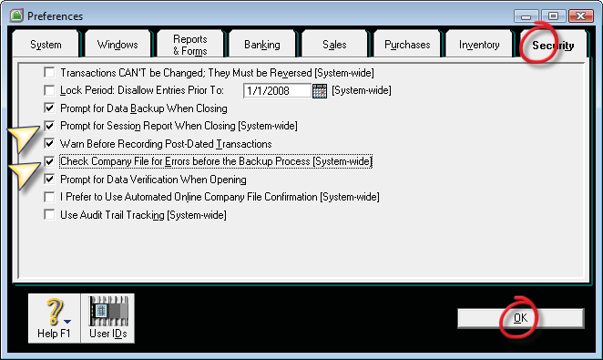

Membuat Kode Pajak

- Menghapus Kode Pajak
  - Lists – Tax Codes
  - Sorot kode pajak, lalu klik Edit (kiri atas menu utama)
  - Klik Delete Tax Code
  - Hapus semua kode pajak dan sisakan kode pajak N-T

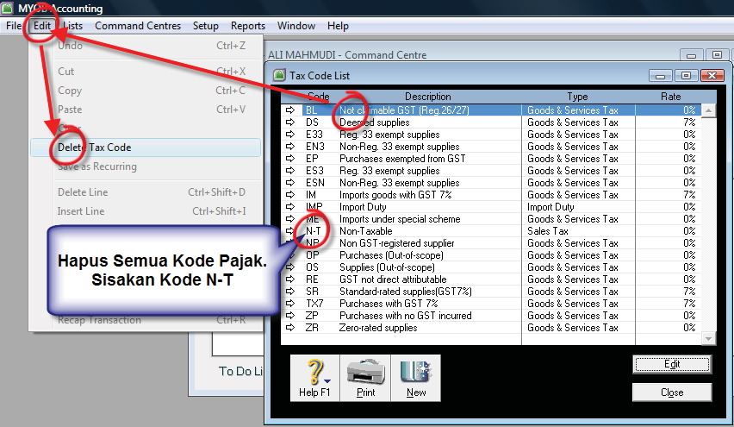
- Membuat Kode Pajak
  - Kilk tombol New di jendela Tax Code List
  - Lalu isikan data PPN /VAT 10% seperti berikut ini:

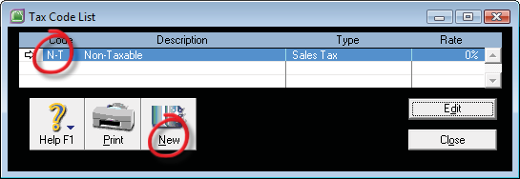

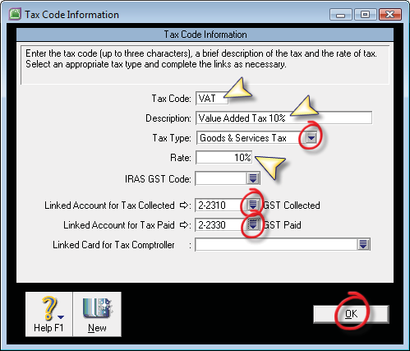

Membuat Kode Job

- Lists – Job – New
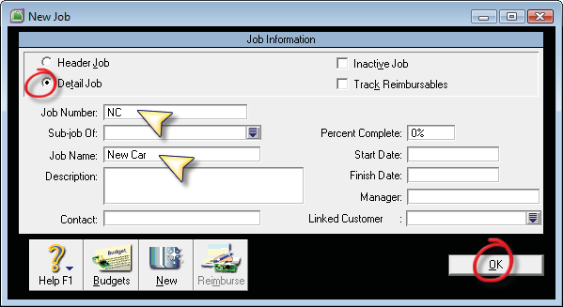
- Isikan kode job seperti berikut ini :

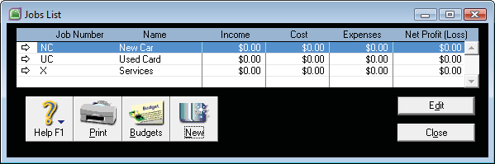

Membuat Kode Category

- Lists – Category – New
- Isikan 2 jenis category seperti berikut ini:

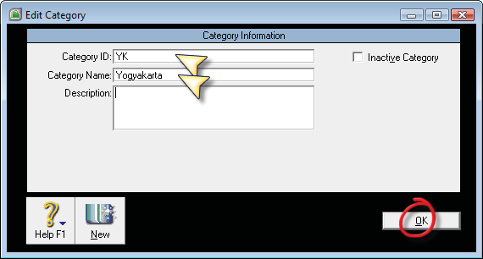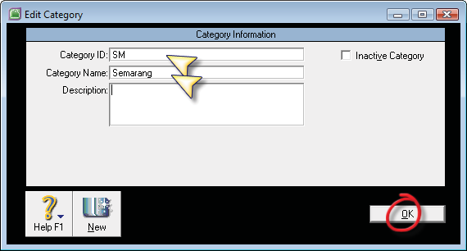

Mengisikan Saldo Awal Neraca

- Buka menu Setup – Balances – Account Opening Balances

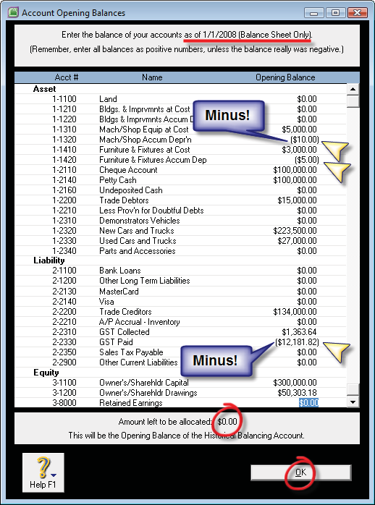

Mengisikan Saldo Awal Piutang - Customer

- Membuat Data Customer
  - Lists – Card – Customer – New
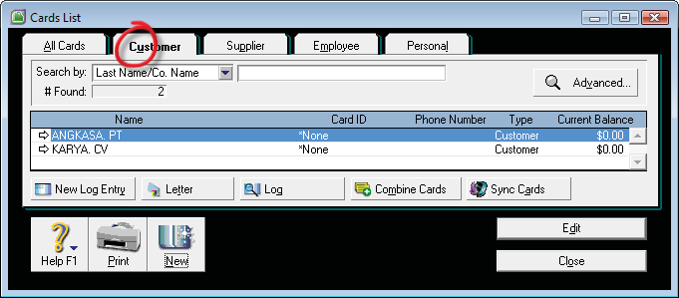
  - Isikan Nama customer

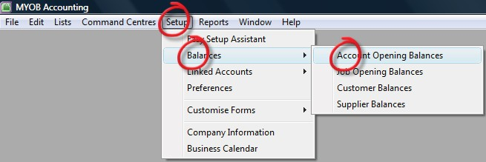

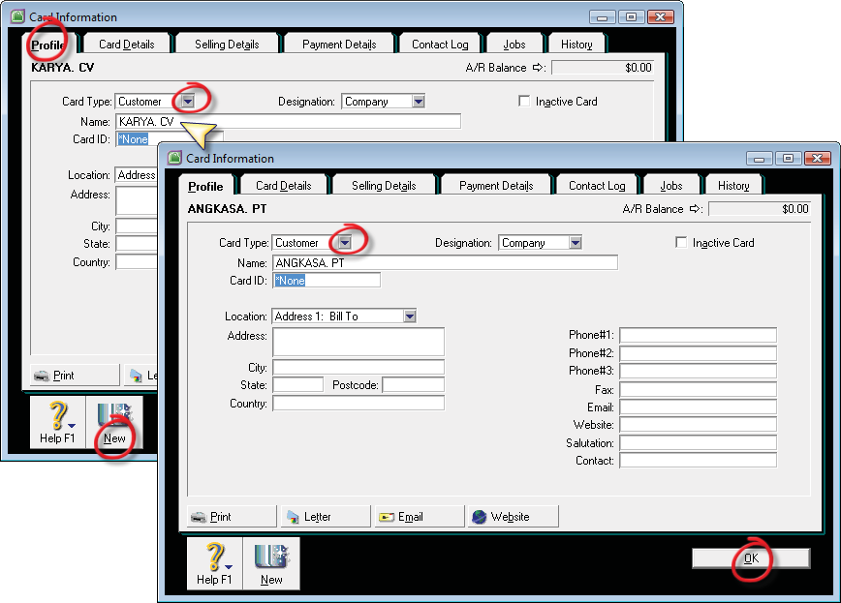
- Mengisikan Saldo awal Piutang pada Customer :
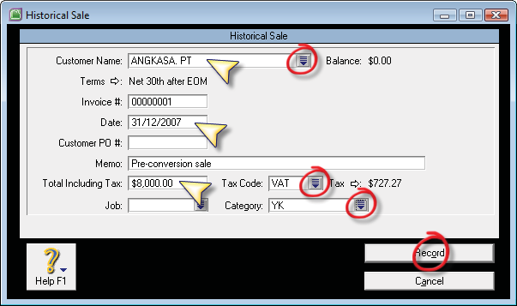
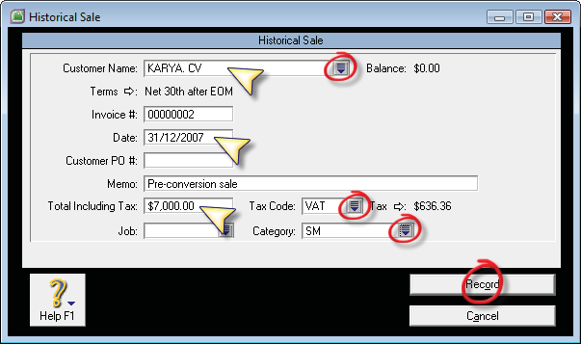
  - Setup – Balances – Customer Balances – Add Sales

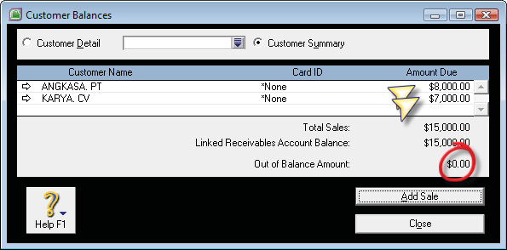

Mengisikan Saldo Awal Utang - Supplier

- Membuat Data Supplier
  - Lists – Card – Supplier – New

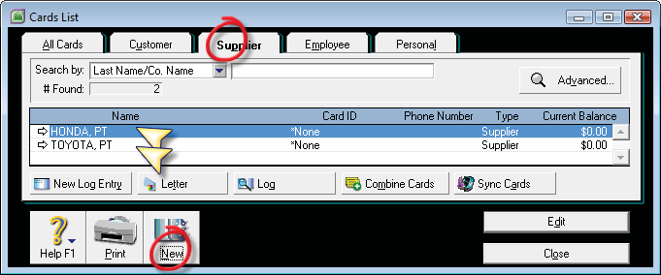
- Mengisikan Saldo awal Utang ke Supplier :
  - Setup – Balances – Supplier Balances – Add Purchases

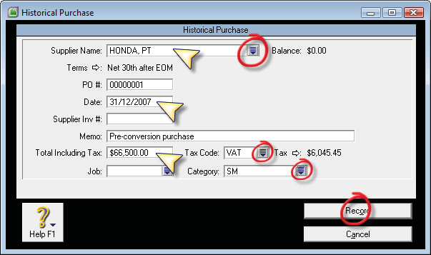

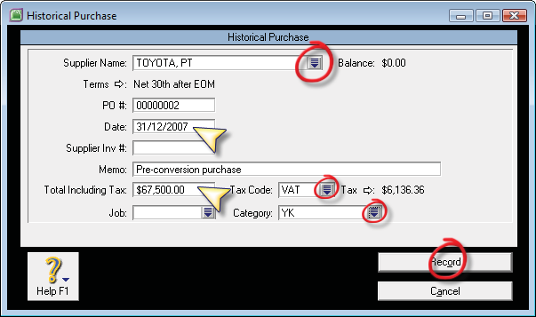
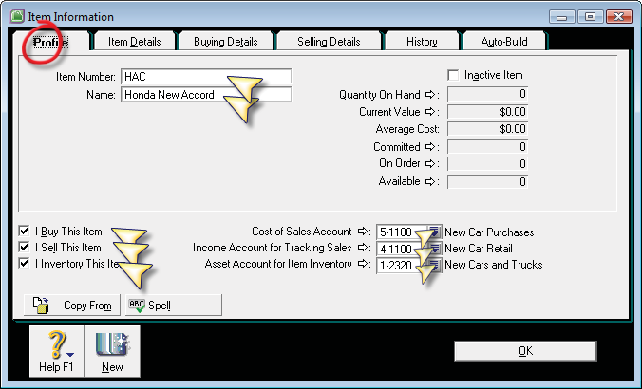

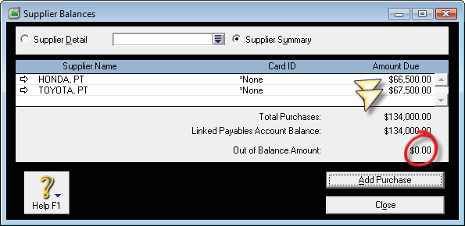
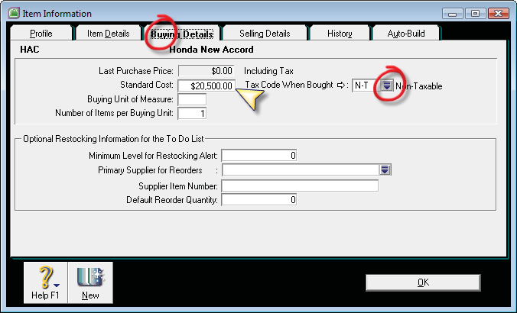
Membuat Data Barang – Item Lists

- Inventory – Item Lists – New
- Buat kode barang : HAC, HCR, TKR dan TKI sebagai kelompok untuk New Car & Trucks.
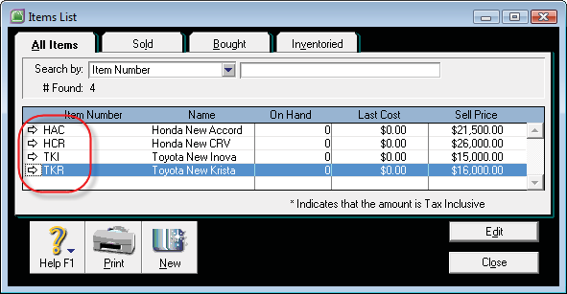
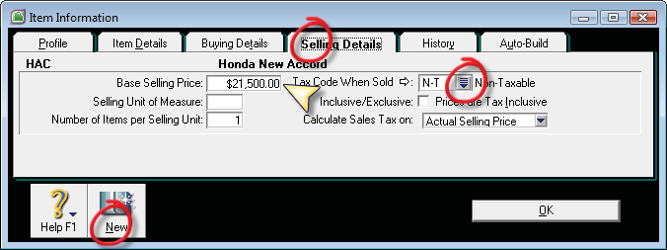

- Buat kode barang : HAS dan TKS sebagai kelompok untuk Second Car & Trucks.
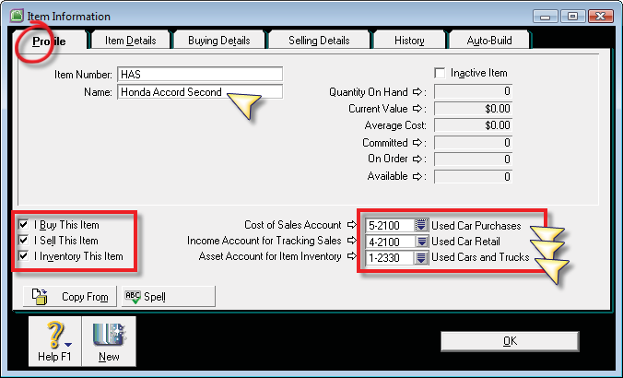

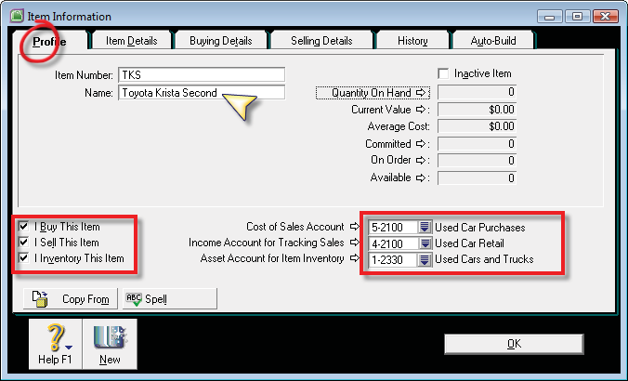
- Mengisikan Harga Jual secara bersamaan :
  - Inventory – Set Item Prices
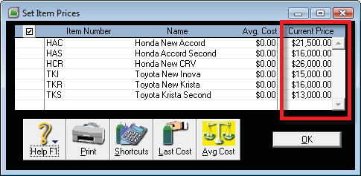
  - Isikan masing-masing harga jual per item. OK.

Mengisikan Saldo Awal Barang Dagang

- Inventory – Adjust Inventory
- Isikan data tentang tanggal, memo, item number, quantity, unit cost, account dan Category.
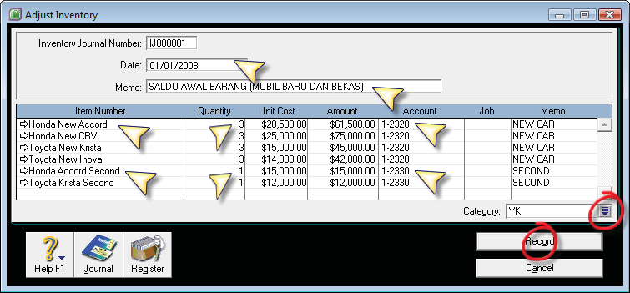
- Tekan Ctrl R untuk melihat jurnalnya. Lalu Klik Record
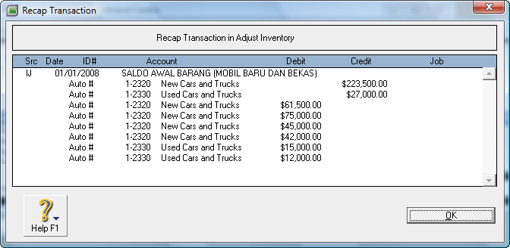

Note :

Jika terdapat kesalahan pengisian saldo barang, baik kuantitasnya, harga per unit maupun akun alokasi persediaanya, bisa dilihat kembali dan diperbaiki dari menu transaction Journal, lalu pilih bagian Inventory, dan tetapkan tanggal transaksi yang telah dimasukkan sebelumnya. Klik anak panah putihnya pada baris transaksi inventory jurnal tersebut, dan akan dimunculkan jendela Inventory Adjustment seperti gambar diatas. Silahkan perbaiki data yang salah.

Transaksi

- On 2 Jan 2018: Purchase the following inventory item from supplier, HONDA, PT, with Net 20th after EOM credit terms. Supplier will give discount: 2% if Company pays before discount date: 5th. (PO#: P- 800001, Supplier Inv#: HND-800001)
- Order 5 unit Honda New Accord (HAC) for $20,500.-/unit (Exclude 10% VAT) each. Company was received only 4 unit of total order.
- Order 3 unit Honda New CRV (HCR) for $25,000.-/unit (Exclude 10% VAT) each. All the order was received. [Category: SM]

PENYELESAIAN :
- Buka menu Purchases – Enter Purchases – BILL
- Supplier : HONDA, PT.
- Layout : Item
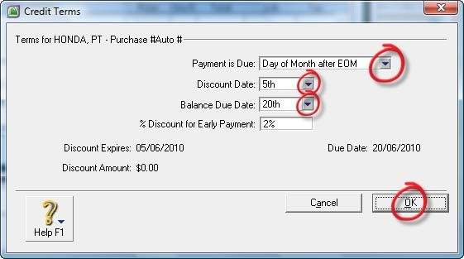
- Terms : klik dan isikan data termin pembayaran seperti berikut ini:
27. On 3 Jan 2018:
- Raised Purchase order from supplier, TOYOTA, PT, for 2 unit Toyota Krista (TKR) @$16,500.-/unit (Include 10% VAT) on net 25th credit terms. The car and bill was received (PO#: P-800002, Supplier Inv#: TYT-800001). [Category: YK]
- Raised Purchase order from supplier, TOYOTA, PT, for 2 unit Toyota Krista - Second Hand (TKS) @$13,200.-/unit (Include 10% VAT) on net 25 credit terms (PO#: P-800003, Supplier Inv#: TYT-800002). The car and Bill was received. [Category: YK]

PENYELESAIAN :
- Buka menu Purchases – Enter Purchases – BILL
- Supplier : TOYOTA, PT.
- Layout : Item
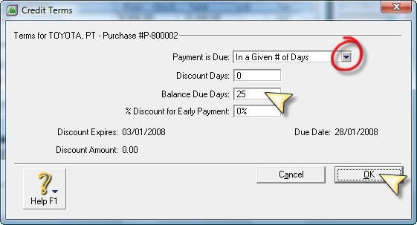
- Terms : klik dan isikan date termin pembayaran seperti berikut ini:

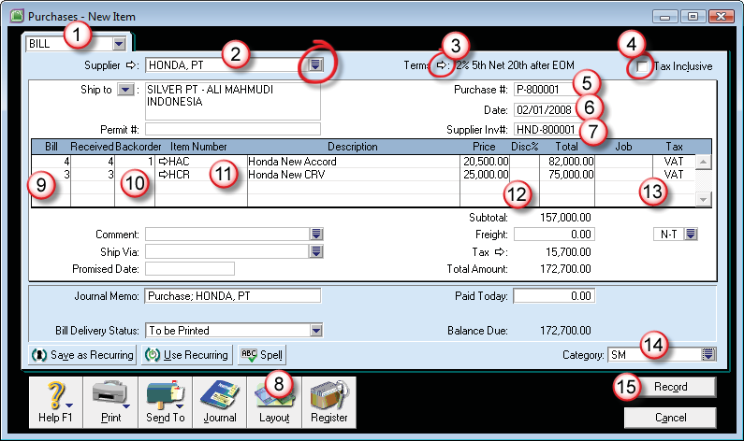
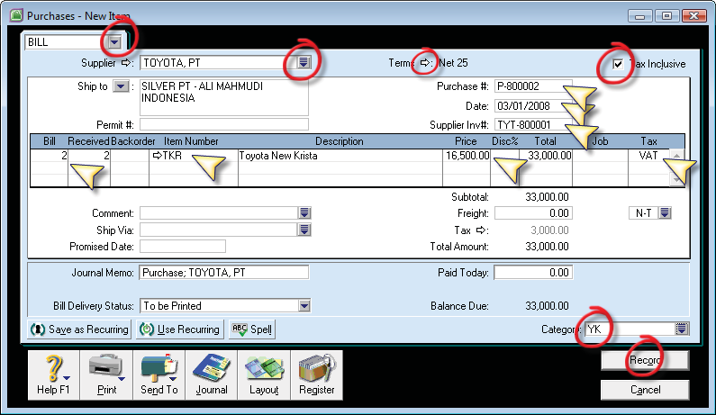

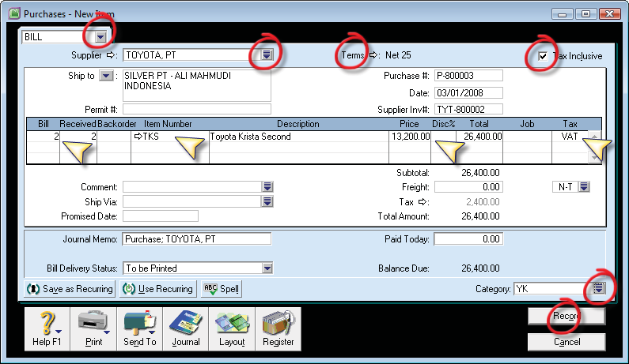
- On 4 Jan 2018: Paid partially to TOYOTA, PT, for total $15,000.-, for Bill on: 31 Dec 2007 ($10,000.-) and 3 Jan 2008 ($5,000.-) using Cheque Account. (NB: Bill on 3 Jan, Paid for Supplier Inv#: TYT-800001).

PENYELESAIAN :
- Buka menu Purchases – Pay Bill
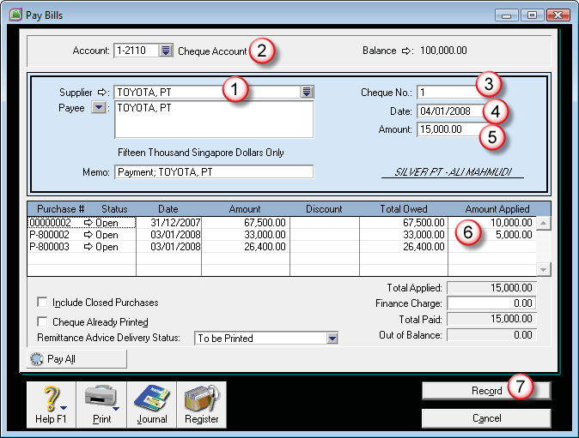
- Supplier : TOYOTA, PT.
- On 5 Jan 2018: Received $150.- purchase rebate from HONDA,PT (PO#: P-800001, Supplier Inv#: HND-800001). Immediately applied the $150.- rebate amount as Discount Taken to Trade Creditor balance for HONDA,PT, as purchase rebate for bill on 2 Jan 2008 transaction. [Job: NC] [Category: SM]

PENYELESAIAN :
- Buka menu Purchases – Enter Purchases – BILL
- Supplier : HONDA, PT., muncul daftar pesanan sebelumnya, tekan Esc atau Cancel atau tekan tombol New.
- Layout : Service
- Isikan data retur/diskon seperti gambar berikut:
- Amount = MINUS!
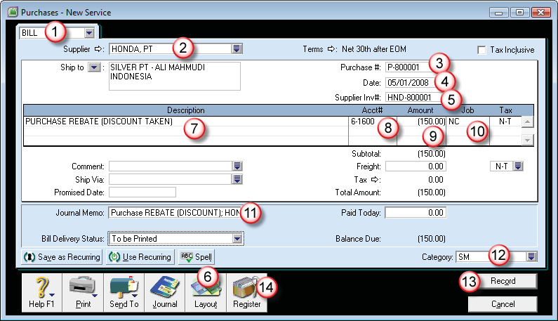
- Klik Register – pilih Returns & Debits
- Klik Apply to Purchase

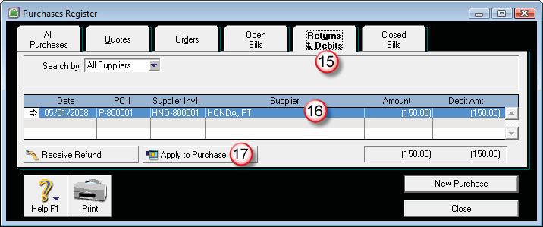

- Isikan tanggal alokasi rebate/diskon, dan klik di bagian baris tagihan yang dikurangkan (Amount Applied). Klik Record.
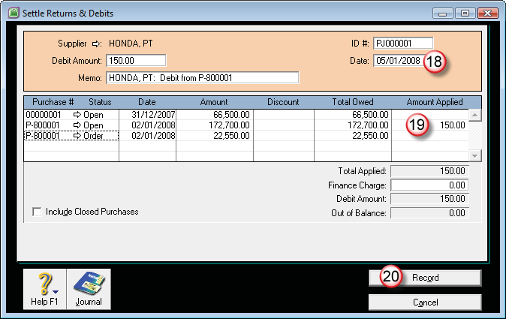
- On 6 Jan 2018: Sold 3 unit of Honda New Accord (HAC) @$21,500.- (Exclude 10% VAT) each to ANGKASA, PT, on net 28th after EOM terms (Inv#: S-800001). [Job: NC] [Category: YK] [Salesperson: Rosa]

PENYELESAIAN :
- Buka menu Sales – Enter Sales – Invoice
- Customer : Angkasa,
- Terms : klik dan isikan data termin berikut ini :
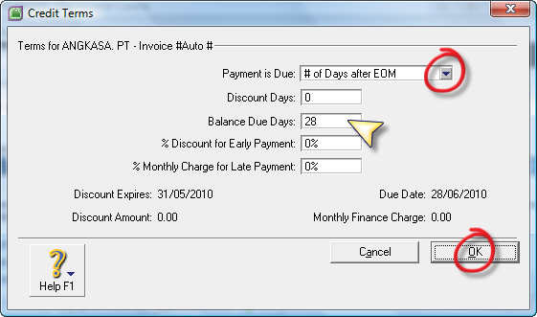
- Layout : Item
- Tax Inclusive : non aktifkan
- Isikan data barang yang dijual
- Salesperson : ketik ROSA, jika datanya belum ada, klik Easy Add.
- Isikan Category, dan Record.

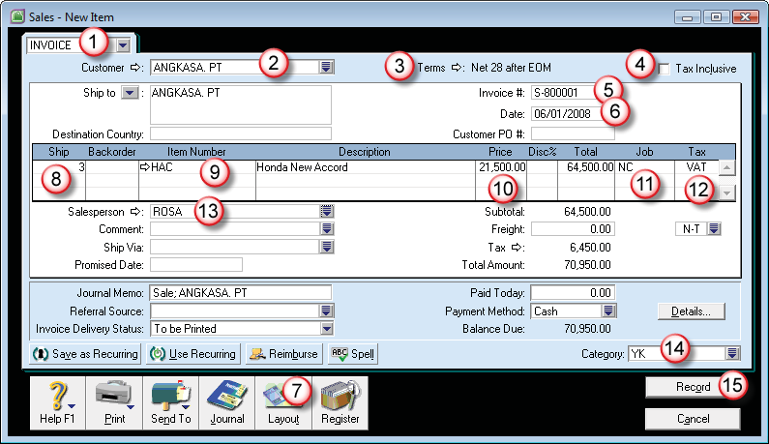
- On 7 Jan 2018: Charge for Car Service Contract for $110.- (include 10% VAT) to KARYA, CV, on cash term (Inv#: S-800002). [Job: X] [Category: SM] [Salesperson: Joni]

PENYELESAIAN :
- Buka menu Sales – Enter Sales – Invoice
- Customer : Karya CV Terms : COD
- Tax Inclusive : aktif Layout : Service
- Isikan data penjualan, isikan job dan kode pajak
- Salesperson : JONI (Easy-Add) Record
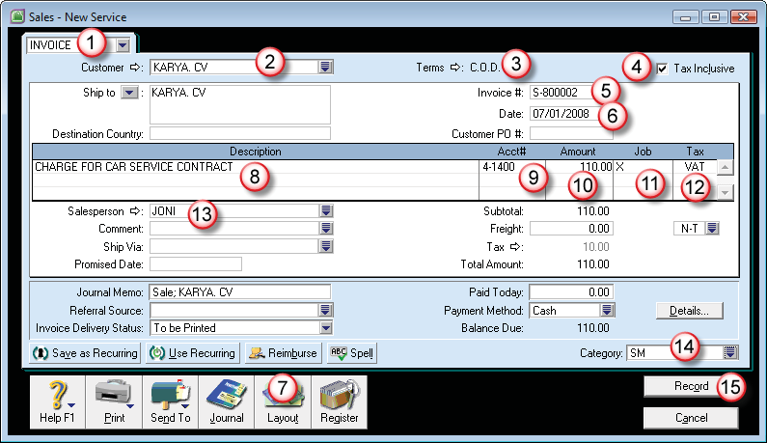

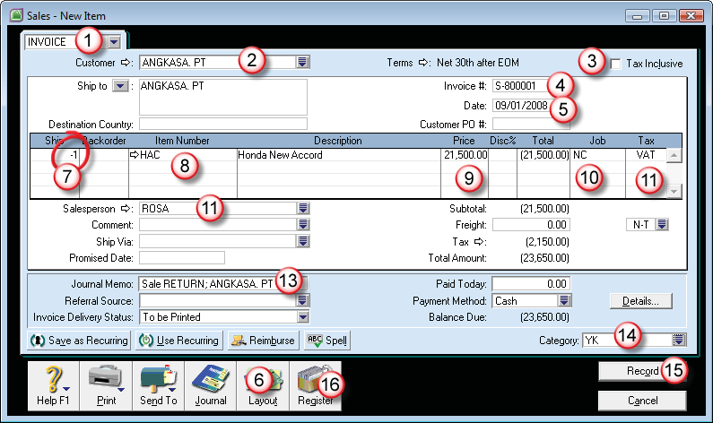
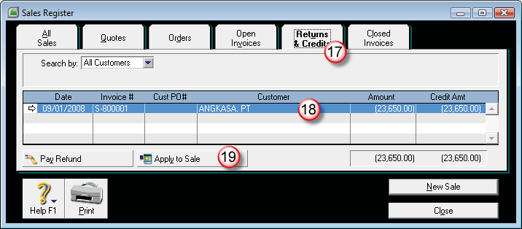
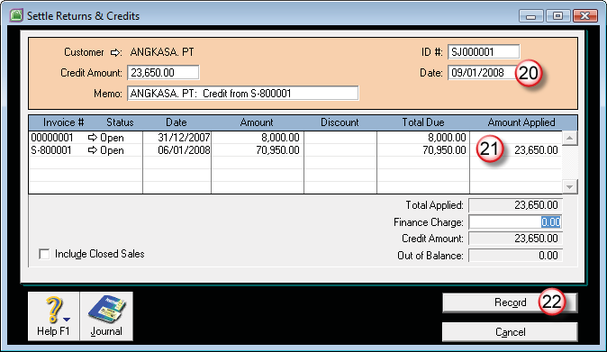
- On 8 Jan 2018: Full payment of $110.- for car service was received from KARYA, CV, and deposit to Petty cash.

PENYELESAIAN :
- Buka menu Sales – Receive Payments
- Isikan data pembayaran tagihan seperti gambar berikut ini:
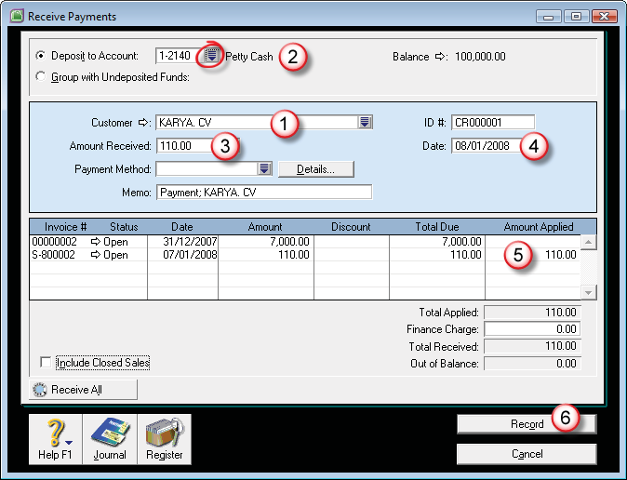
- On 9 Jan 2018: Return 1 unit Honda New Accord (HAC) @$21,500.- (Exclude 10% VAT) from customer, ANGKASA, PT (Inv#: S-800001). Immediately applied the Credit Note to Trade Debtor balance for ANGKASA, PT for invoice on 6 Jan 2008 transaction. [Category: YK] [Salesperson: Rosa]

PENYELESAIAN :
- Buka menu Sales - Enter Sales – Invoice
- Customer : ANGKASA
- Isikan data retur barang, kolok Ship isikan dengan nilai MINUS!
- Klik Record
- Klik Register
- Return & Credits – Apply to Sale
- Alokasikan faktur yang di retur
- Record

- On 10 Jan 2018: Issued $10.- sales rebate to KARYA, CV, as Car Service Contract (Inv#: S-800002). Immediately pay refund for $10.- Car Service Rebate to KARYA, CV, from Petty cash. [Job: X] [Category: SM] [Salesperson: Joni]

PENYELESAIAN :
- Sales – Enter Sales – INVOICE
- Customer : KARYA
- Layout : Services
- Account : Discount GIVEN
- Amount : MINUS!
- Isikan data job, salesperson, Journal Memo, Category
- Klik Record.
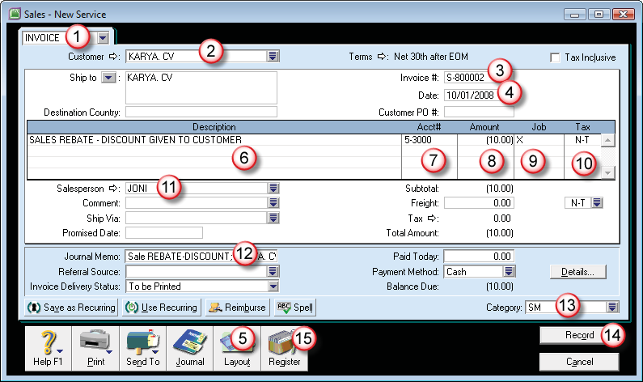
- Klik Register, Return & Credits – Pay Refund.

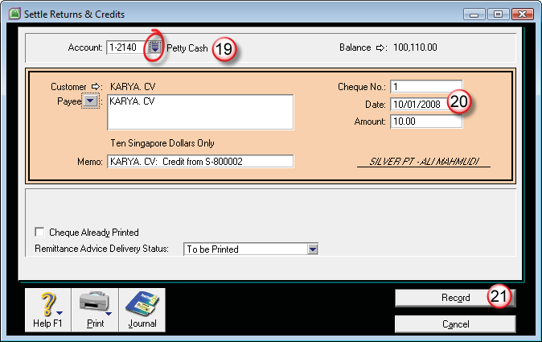

- On 11 Jan 2018: Use spend money, Transfer $400.- to Cheque Account from Petty Cash ($410.-), and pay $10.- as Bank Charges. [Category: YK]

PENYELESAIAN :
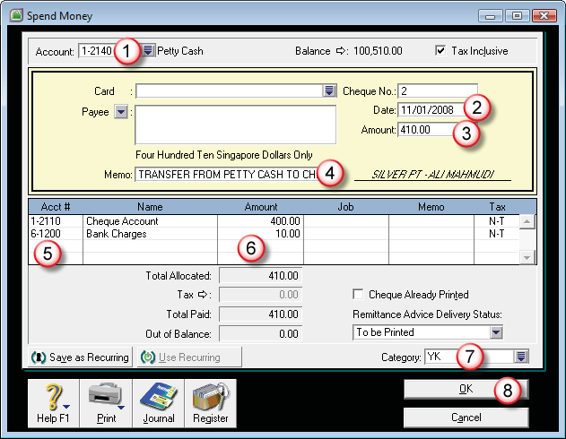
- Buka menu Banking – Spend Money

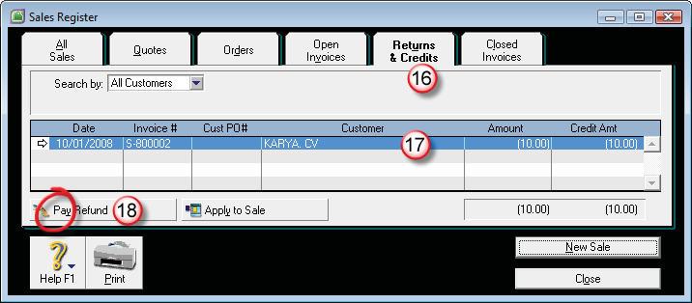

- On 12 Jan 2018: Received $10.80 as Bank Interest Income with $0.80 Bank Charges on Cheque Account, [Category: YK]

PENYELESAIAN :
- Banking – Receive Money
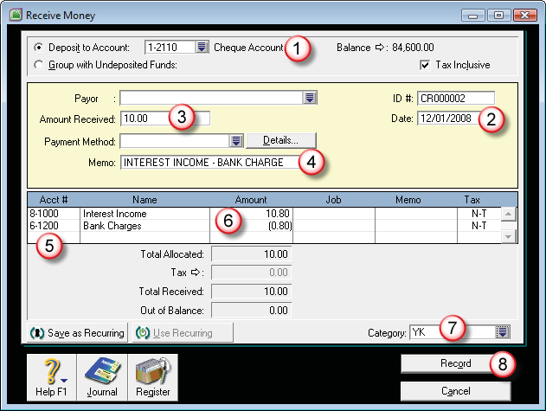

- On 31 Jan 2018: Perform Bank Reconciliation for Cheque Account. Bank Statement Balance is $85,410.

PENYELESAIAN :
- Banking – Reconcile Account, Account : Cheque Account
- Bank Statement Date : 31/01/2018
- New Statement Balance : ketik 85.410
- On 31 Jan 2018: Prepare a Journal entry to record:
  - Mach/Shop Equipment Depreciation at $10.- [Category: YK] Save as Monthly Recurring Transactions. Use the recurring and record depreciation journal for 28 Feb 2018.
  - Furniture & Fixtures Depreciation at $5.- [Category: YK] Save as Annually Recurring.

PENYELESAIAN :
- Accounts – Record Journal Entry
- Isikan Jurnalnya, klik Save as Recurring
- Pilih Frequency : Monthly, Starting on : 28/02/2018
- Klik Save (Recurring)
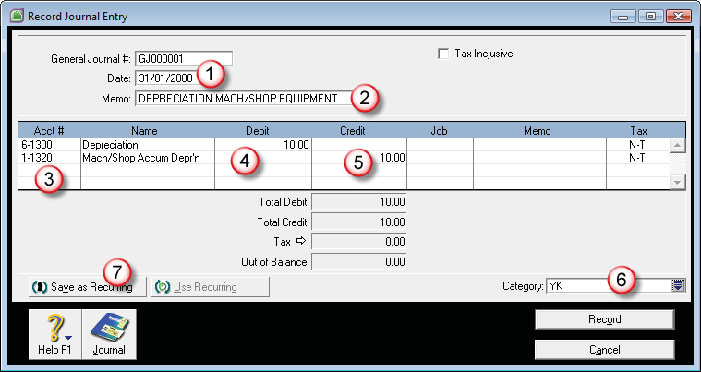
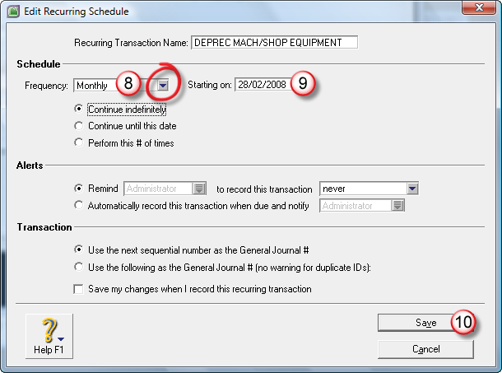
- Klik Record (Record Journal Entry).

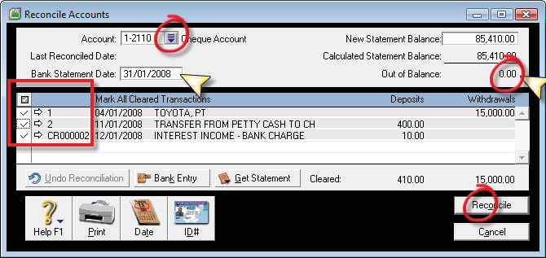

- Accounts – Record Journal Entry
- Isikan Jurnalnya Penyusutan Furniture & Fixture,
- klik Save as Recurring
- Pilih Frequency : Annually, Starting on : 31/01/2018
- Klik Save (Recurring)
- Klik Record (Record Journal Entry).
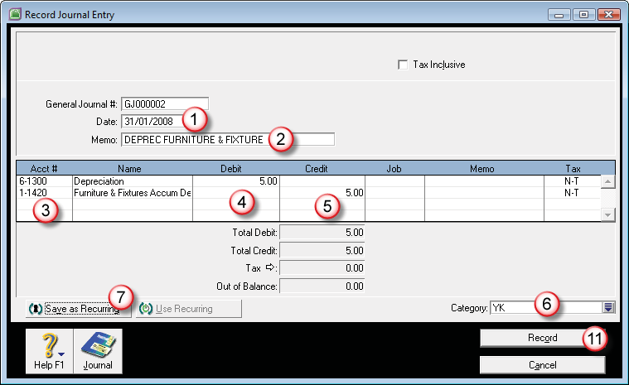

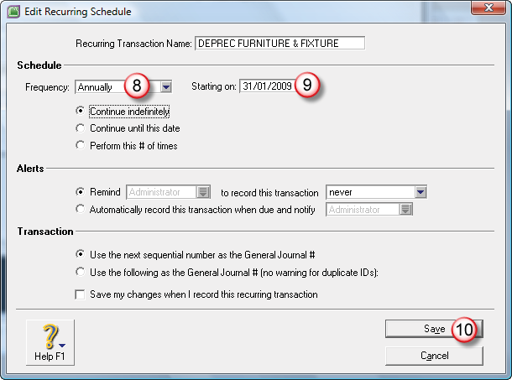
- Buka menu Lists – Recurring Transaction
- Sorot baris recurring bulanan (Monthly)
- klik Use Recurring

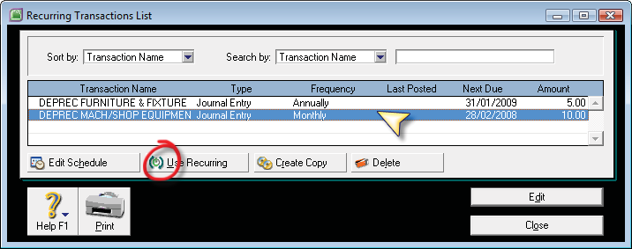
- akan dimunculkan jendela Record Journal Entry
- ganti tanggal transaksi ke tanggal 28/02/2018
- Record.
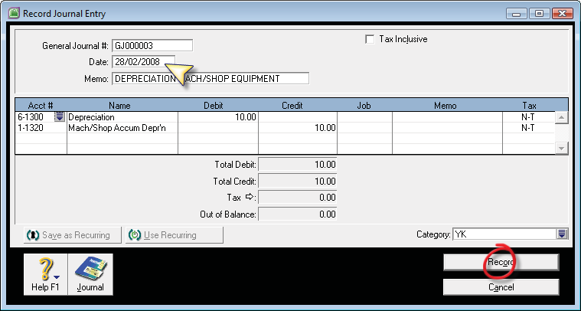

- On 31 Jan 2018: Build Item for Inventory Exchange: for 2 Unit of Toyota Krista - Second Hand (TKS) @$12,500.- with 1 Unit Honda New CRV (HCR) @$25,000.-. [Category: YK]

PENYELESAIAN :
- Buka menu Inventory – Build Item
- Isikan tanggal : 31/01/2018
- Memo : keterangan
- Item Number : item yang di tukar (Baru) Quantity : MINUS
- Item Number : baris kedua, isikan dengan item yang didapatkan dari hasil penukaran (Second), Quantity : Plus
- Category : YK
- Record.

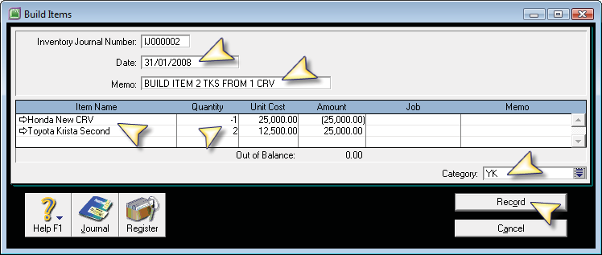

- On 31 Jan 2018: Sent to PDF the financial Reports for period of January (1 Jan to 31 Jan 2018). Save the reports in Reports Folder.
  - Trial Balance,
  - Recurring Transactions,
  - Card List Summary,
  - Analyze Inventory Summary,
  - Item List Summary,
  - Account Transaction (Accrual) and
  - VAT (Detail-Accrual)

PENYELESAIAN :
- Buka menu Reports – Accounts
- Tampilkan Laporan per tanggal 31 Jan 2018
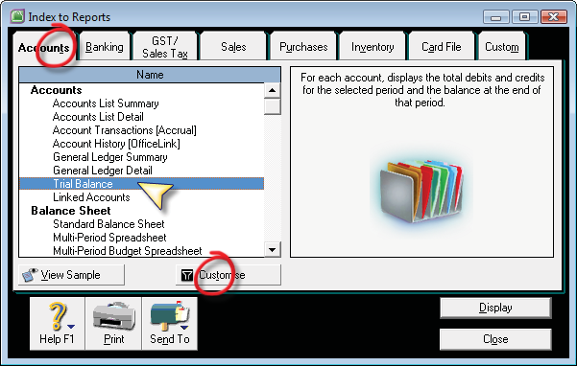

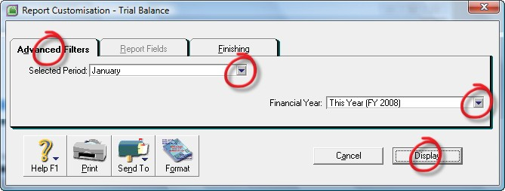

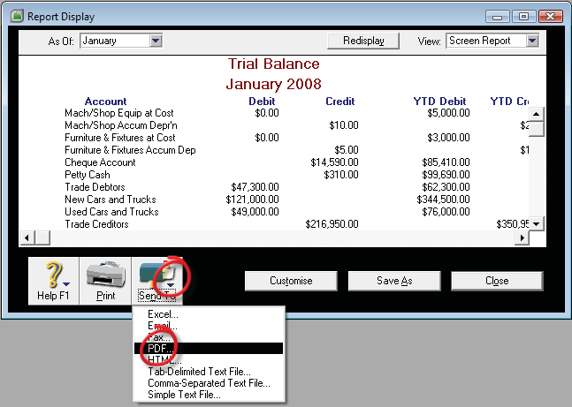

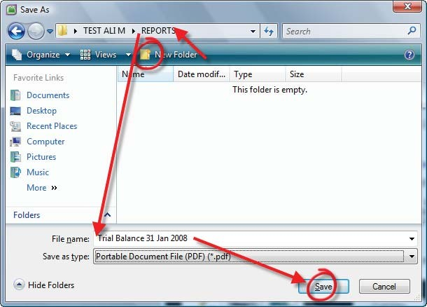
- Recurring Transaction : Reports – Accounts – Recurring Transaction List (paling bawah di daftar Reports – Accounts)

- Card List Summary
  - Reports – Card File – Card List Summary
- Analyse Inventory Summary
  - Reports – Inventory – Analyse Inventory Summary
- Item List Summary
  - Reports – Inventory – Item List Summary
- Account Transaction (Accrual)
  - Reports – Accounts – Account Transactions (Accrual)
- VAT (Detail Accruals)
  - Reports – GST/Sales Tax – VAT/GST (Detail Accrual)
- BACKUP your MYOB Company data file (ONLY), Check Company File for Error and Save the MYOB company data backup file name as Your Name in Backup Folder. From Security Preference, active the option for “Use Audit Trail Tracking”, then Lock the Accounting period for Jan 2018.

PENYELESAIAN :
- Buka menu Setup – Preferences – Security
- Aktifkan piliah Lock Period Disallow Entries Prior to : 31/01/2018
- Aktifkan pilihan Check Company File for Errors before ....
- Aktifkan pilihan Use Audit Trail Tracking
- Klik OK.
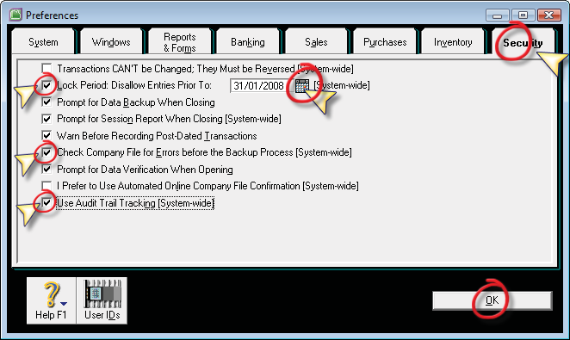

- File – Backup...
- Pilih Backup Company File Only dan Check Company File for Errors
- Klik Continue
- File Name : ketik nama file Backup
- Save.

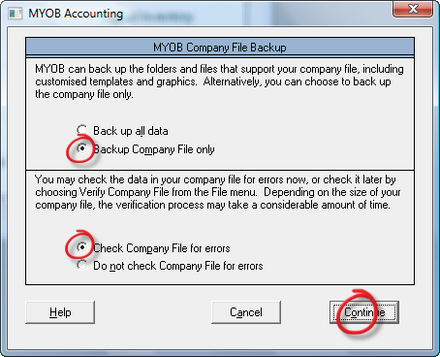

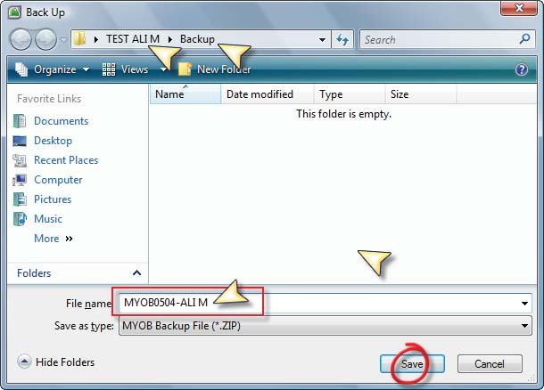

- Edit payment to TOYOTA, PT on 4 Jan 2018 to: Pay total $15,000 from Petty Cash, pay for Bill on 31 Dec 2017 ($7,500.-) and Bill on 3 Jan 2017 ($7,500.-). Keep the Cheque or Voucher No. record as No. 1. (NB: Bill on 3 Jan, Paid for Supplier Inv#: TYT-800001)

PENYELESAIAN :
- Transaksi Pay Bill yang sudah di posting tidak bisa diganti jika terjadi kesalahan pemilihan supplier dan alokasi invoice yang di bayarnya.
- Oleh sebab itu kita harus menghapus transaksi tersebut
- Dikarenakan sudah di Lock Period di Preferences, maka untuk menghapus transaksi yang lalu, kita harus membuka kembali Lock Period tersebut.
- Buka menu Setup – Preferences – Security – untick Lock Period ....

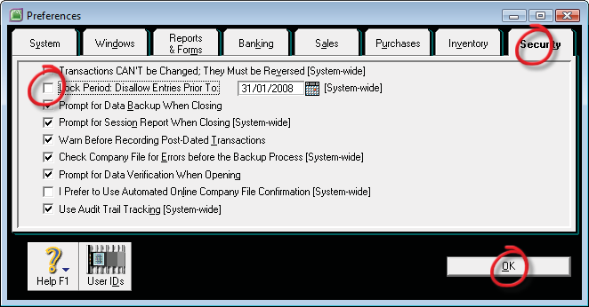
- Buka Transaction Journal – Disbursement – Date From : 04/01/2018
- Klik anak panah transaksi tanggal 04 Januari 2008
- Setelah terbuka transaksi Pay Bills
- Klik menu Edit (menu utama), lalu klik Delete Payment
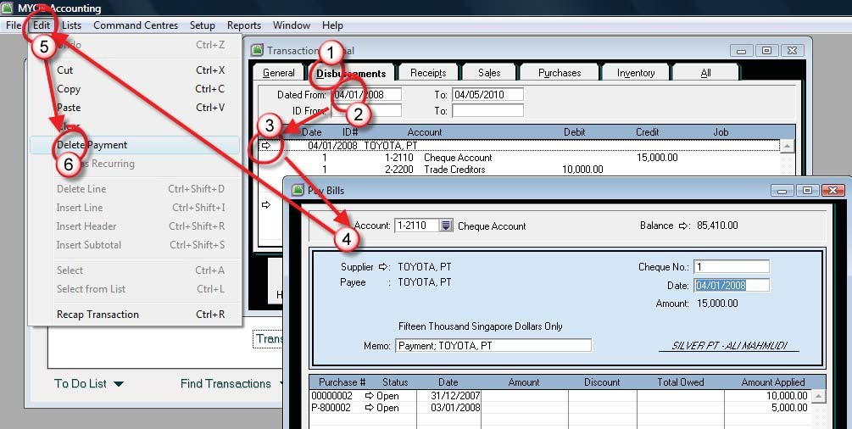

- Setelah terhapus transaksi yang salah tersebut, lalu lakukan transaksi Pay Bill lagi yang benar.
- Klik menu Purchases – Pay Bills
- Supplier : Toyota
- Account : Petty Cash
- Cheque # : 1
- Date : 4/1/2018
- Amount : 15.000
- Amount Applied : baris pertama 7.500 dan baris kedua 7.500
- Record

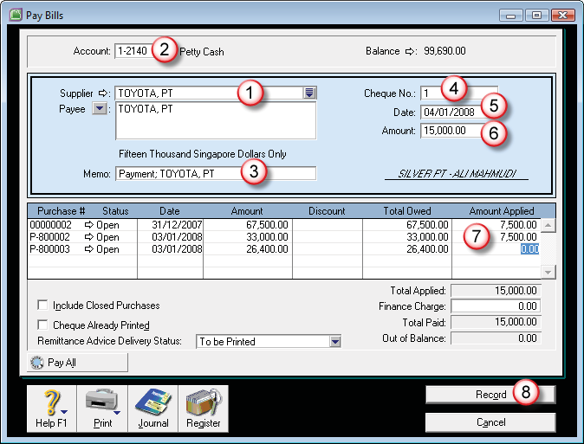

- From Company Data Auditor – Transaction Review for 1 Jan 2018 to 31 Jan 2018, there is a “?” mark for Scan for Futures Dated Transactions. Display & Sent to PDF: The Future Dated Transactions Report.

PENYELESAIAN :
- Buka menu Accounts – Company Data Auditor
- Transaction Review – Start Date : 01/01/2018 End Date : 31/01/2018
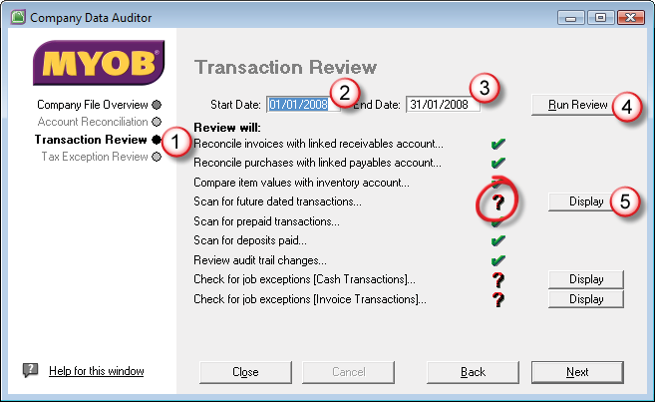
- Run Review – Scan for future date transactions... – klik Display

- Setelah tampil preview laporan yang tanda muncul tanda tanyanya, klik Send To – PDF dan simpan nama filenya.

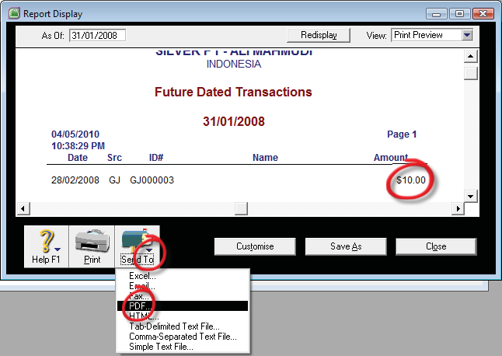

- Edit the value of Mach/Shop Equipment Depreciation for Journal Entry on 28 Feb 2018 to $15.- and edit the Recurring Transaction Template of Mach/Shop Equipment Depreciation to $15.- per month.

PENYELESAIAN :
- Buka menu Transaction Journals – General – Date From : 01/02/2018to 28/02/2018
- Klik anak panah transaksi tanggal 28 Jan 2018
- Ganti nilai jurnalnya dari 10 menjadi 15.
- Klik OK.

- Untuk mengedit Recurring jurnal yang sudah disimpan :
- Lists - Recurring Transaction
- Double klik baris recurring kedua (monthly)
- Ubah nilainya dari 10 menjadi 15
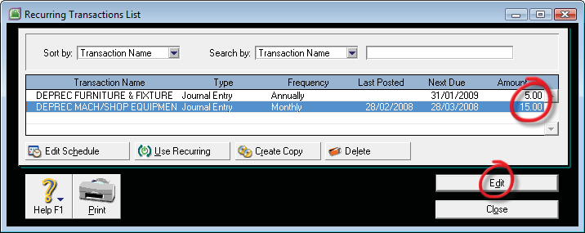
- Kill Save.

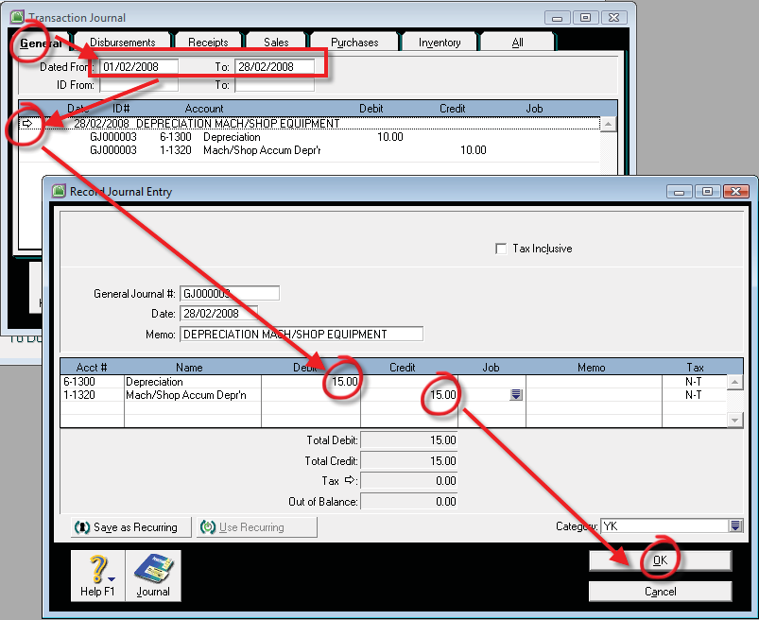

- Display & Sent Report to: Tab Delimited Text File Format the financial Reports for period of January (1 Jan to 31 Jan 2018).
Save the reports in Reports Folder.
  - Std Balance Sheet Reports – Accounts – Balance Sheet
  - Profit & Loss (Accrual) Reports – Accounts – Profit & Loss
  - Job P&L Reports – Accounts – Jobs
  - Category P&L Reports – Accounts – Category
  - G/L Summary Reports – Accounts – Accounts
  - Account Transaction (Acrual) Reports – Accounts – Accounts
  - VAT (Detail-Accrual) Reports – GST/VAT Sales Tax

PENYELESAIAN :
- Buka menu Reports – Accounts
- Tampilan jenis dan kelompok laporan serta periode yang di inginkan
- Setelah tampil di layar, klik Send To PDF
- Simpan nama file kedalam folder report
- Save.

