Praktikum Topik 12 (Praktikum Fungsi03) :
Output program :
Menu Program
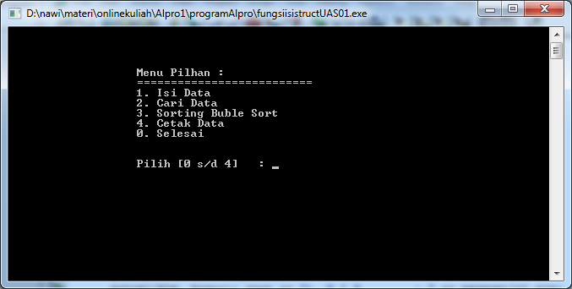
Input Data
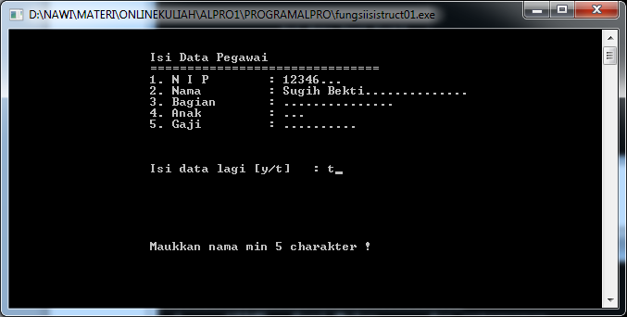
Setelah diisi, dicetak dengan hasil :
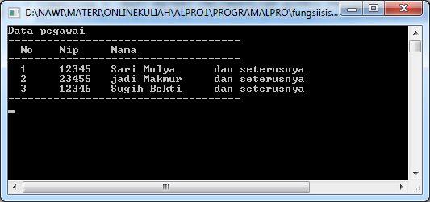

Tambahkan kode program berikut, sehingga semua isian dapat diinputkan !
Kode Program :
#include <iostream.h>
#include <conio.h>
#include <stdio.h>

// membuat variabel struct...............................
struct spegawai
{
int nip;
char nama[30];
char bagian[15];
int anak;
int gaji;
};

//mendefinisikan var. pegawai dengan struct spegawai....
spegawai pegawai[10];

//var data....
int indexdata = 0;

int klm;
int brs;
int klmisi = 38;

char isiket[30];

// fungsi cetak garis........................
void garis()
{
cout << "===============================" << endl;
}

// fungsi cetak judul........................
void cetakTampilan()
{
clrscr();
klm = 20;
brs = 3;
gotoxy(klm, brs++);cout << "Isi Data Pegawai" << endl;
gotoxy(klm, brs++);garis();
gotoxy(klm, brs++); cout << "1. N I P : ........ ";
gotoxy(klm, brs++); cout << "2. Nama : ......................... ";
gotoxy(klm, brs++); cout << "3. Bagian : ............... ";
gotoxy(klm, brs++); cout << "4. Anak : ... ";
gotoxy(klm, brs++); cout << "5. Gaji : .......... ";
gotoxy(klm, brs+=3); cout << "Sudah benar [Enter] : ";
}

//cetak keterangan.......................
void ketisi()
{
gotoxy(klm, 20); cout << " ";
gotoxy(klm, 20); cout << isiket;
}

//isi nip.......................
void isiNip()
{
strcpy(isiket,"Maukkan nip 9000 s/d 99999");
ketisi();

brs = 5;
gotoxy(klmisi, brs); cout << "........ ";
gotoxy(klmisi, brs); cin >> pegawai[indexdata].nip;
if ((pegawai[indexdata].nip < 9000) || (pegawai[indexdata].nip > 99999))
isiNip();
}

//isi nama.......................
void isiNama()
{
strcpy(isiket,"Maukkan nama min 5 charakter !");
ketisi();

brs = 6;
gotoxy(klmisi, brs); cout << "......................... ";
gotoxy(klmisi, brs); gets(pegawai[indexdata].nama);

//mmengecek jumlah karakter nama.....
int jumlah=0;
for (int x=0;pegawai[indexdata].nama[x];x++)
jumlah++;

//jika karakter nama kurang dari 5 huruf isi lagi
if (jumlah < 5)
isiNama();
}

//isi bagian, anak dan gaji buat sendiri .......................
void isiBagian()
{
//buat sendiri ya.....
}

//cetak data............................................
void cetakData()
{
int no;
int jmldata = indexdata;
clrscr();
cout << "Data pegawai " << endl;
cout << "====================================" << endl;
cout << " No Nip Nama " << endl;
cout << "====================================" << endl;
for (int ndata=0; ndata<jmldata; ndata++)
{
no = ndata + 1;
cout << " " << no << "\t";
cout << pegawai[ndata].nip << "\t";
cout << pegawai[ndata].nama << "\t";
cout << "dan seterusnya" << "\t";
cout << endl;
}
cout << "====================================" << endl;
getch();
}

//menu program............................................
void menuNIM()
{
clrscr();
klm = 20;
brs = 5;
gotoxy(klm, brs++);cout << "Menu Pilhan :";
gotoxy(klm, brs++);cout << "==========================";
gotoxy(klm, brs++);cout << "1. Isi Data";
gotoxy(klm, brs++);cout << "2. Cari Data";
gotoxy(klm, brs++);cout << "3. Sorting Buble Sort";
gotoxy(klm, brs++);cout << "4. Cetak Data";
gotoxy(klm, brs++);cout << "0. Selesai";
brs += 2;
gotoxy(klm, brs++);cout << "Pilih [0 s/d 4] : ";
}

//fungsi Isi Data...........................................
void isiData()
{
cetakTampilan();

//isi data........................
isiNip();
isiNama();
//untuk isian yg lain tambahkan sendiri ya.......

//lokasi index ditambah satu......
//setelah simpan data.............
indexdata++;

gotoxy(44, 13); getche();
}

//fungsi cari Data....................................
//menggunakan protiping function......................
void cariData();
//detail isi fungsi ditaruh setelah main()............

//program utama.......................................
void main()
{
// membuat variabel lokal............................
int pilih;

while (true)
{
menuNIM();
gotoxy(40, 14); cin >> pilih;
switch (pilih)
{
case 1:
isiData();
break;
case 2:
cariData();
break;
case 3:
cariData();
break;
case 4:
cetakData();
break;
default :
break;
} //tutup switch.............

if (pilih==0)
break;
} //tutup while................

} //tutup main......................

//menggunakan teknik prototyping function..................
//fungsi Cari Data...........................................
void cariData()
{
cetakTampilan();

//isikan nip yg dicari........................
int xcari;
gotoxy(klmisi, 5); cin >> xcari;

//cari data.......................
int c = 0;
int xdata = indexdata;
while ( c < xdata)
{
if (xcari == pegawai[c].nip)
{
//cetak data.....................

klm = 20;
brs = 3;
gotoxy(klm, brs++);cout << "Data Pegawai Ditemukan " << endl;
gotoxy(klm, brs++);garis();
gotoxy(klm, brs++); cout << "1. N I P : " << pegawai[c].nip;
gotoxy(klm, brs++); cout << "2. Nama : " << pegawai[c].nama;
brs += 3;
gotoxy(klm, brs+=3);

break;
}
c++;
}

if (c == xdata)
{
//data tidak ditemukan.................
gotoxy(klm, 13);
cout << "Data Tidak Ditemukan !";
}
getche();
} //tutup cari data...............................

