Topik 4 Stack (infixpostfix)
Jumat, 23 Oktober 2020

Latihan 1 :
Kode program :

//header program................................................
#include<stdio.h>
#include<conio.h>
#include<iostream.h>
#include<stdlib.h> // for exit().................
#include<ctype.h> // for isdigit(char ).........
#include<string.h>

#define SIZE 100

char stack[SIZE];
int top = -1;

//define push operation.........................................
void push(char item)
{
if(top >= SIZE-1)
{
cout << "\nStack Penuh ! ";
}
else
{
top = top+1;
stack[top] = item;
}
}

//define pop operation..........................................
char pop()
{
char item ;

if(top <0) {
cout << "Stack Kosong ! ";
getchar();
exit(1);
}
else {
item = stack[top];
top = top-1;
}
return(item);
}

//operator yang diijinkan.......................................
int is_operator(char symbol)
{
If (symbol == '^' || symbol == '*' || symbol == '/' ||
symbol == '+' || symbol =='-')
{
return 1;
}
else
{
return 0;
}
}

//mengecek derajat operator.....................................
int precedence(char symbol)
{
if(symbol == '^')
{
return(3);
}
else if(symbol == '*' || symbol == '/')
{
return(2);
}
else if(symbol == '+' || symbol == '-')
{
return(1);
}
else
{
return(0);
}
}

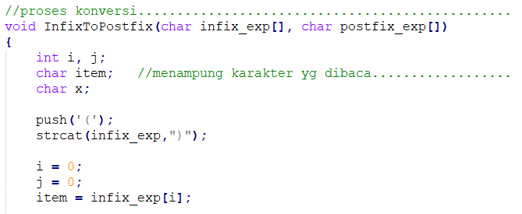
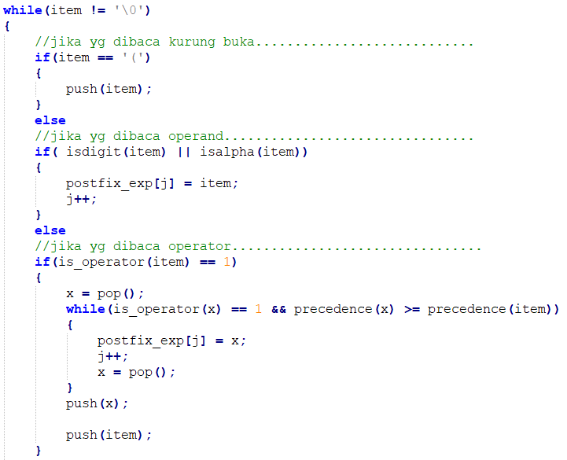
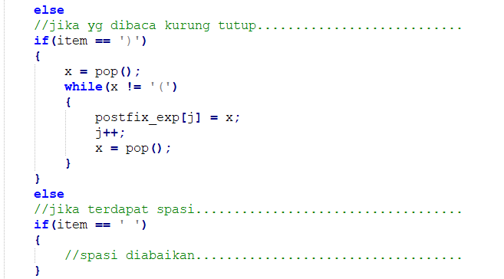
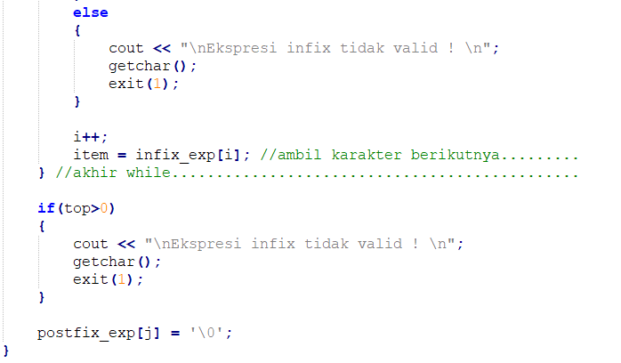

//program utama..................................................
void main()
{
char infix[SIZE], postfix[SIZE];

cout << "Program Konvesi Infix ke Postfix\n";
cout << "\nMasukkan notasi Infix : ";
gets(infix);

//konversikan infix ke postfix................................
InfixToPostfix(infix, postfix);

cout << "Postfix yang terbentuk : ";
cout << postfix;

getch();
}

Output program :
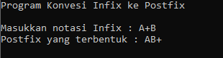

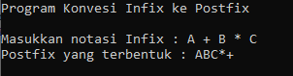

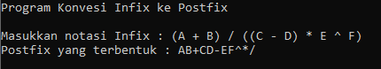

Tugas : (stack konversi infix ke postfix)
Apa output program jika diisikan :
- ( A + B ) / ( C – D )
- A + B / C – D
- A * B + C / D
- A * ( B + C ) / D

Berapa hasil perhitungan dari masing-masing soal diatas jika A = 5, B= 4, C = 2, dan D = 1

DIKUMPULKAN :
Nama File : A12P99AlproXXXXXNama (99 nomor tugas, XXXXX : 5 digit NIM terakhir)
Format file : PDF
Dikirim ke : suharnawi@dsn.dinus.ac.id
Dikumpulkan paling lambat 26 Oktober 2020

