Topik 9 SLLNC / Link List (Pertemuan 11)
Jumat, 18 Desember 2020

Latihan 1 :
Kode program :

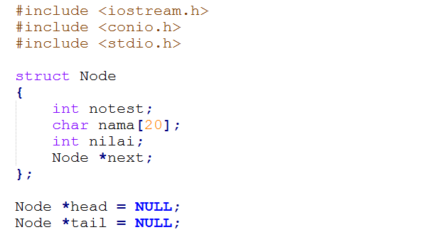
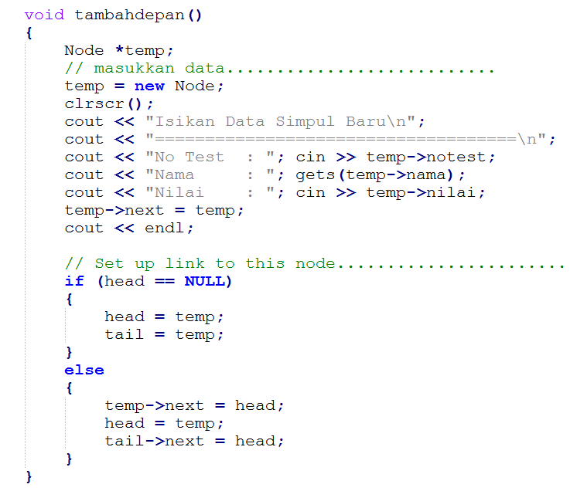
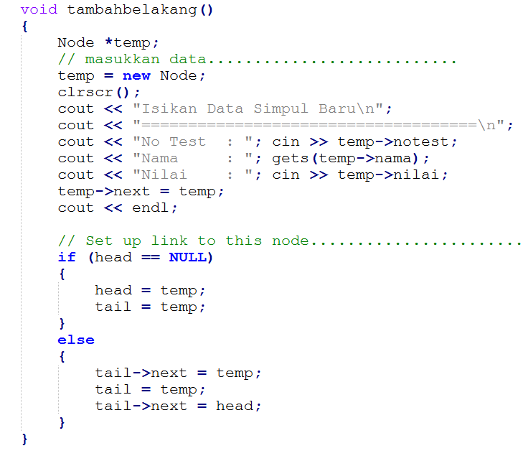
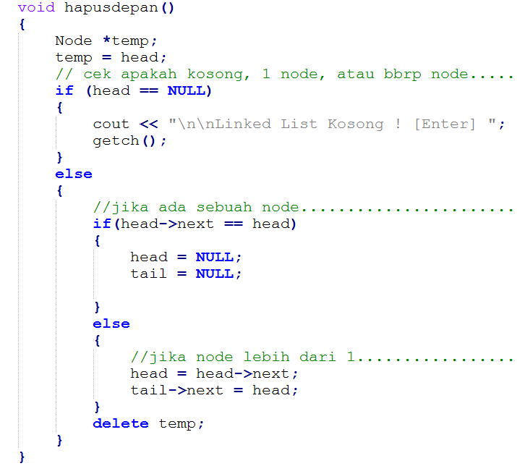
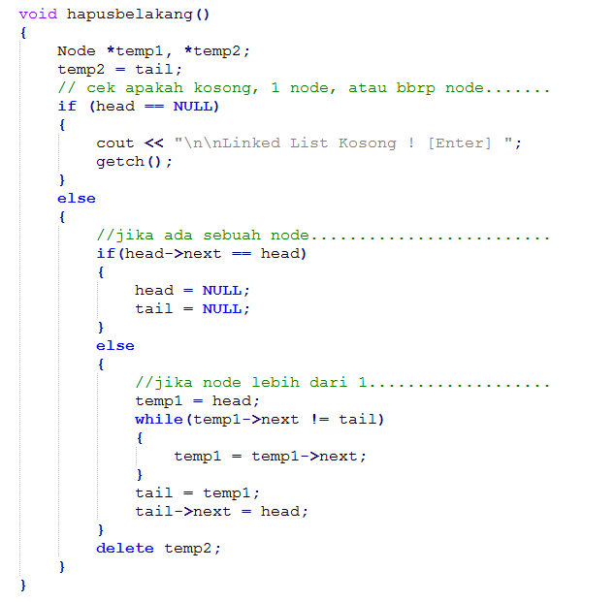
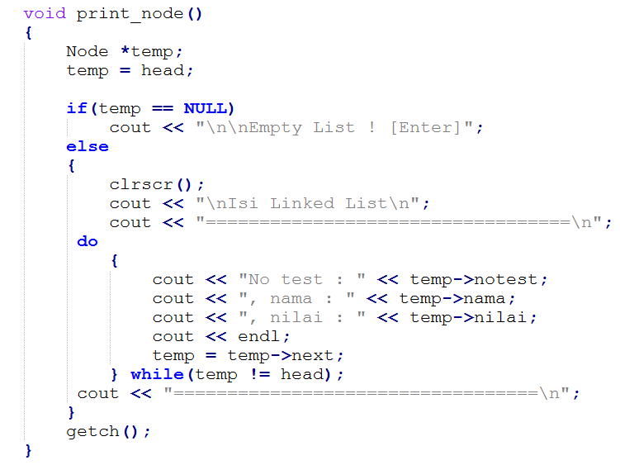
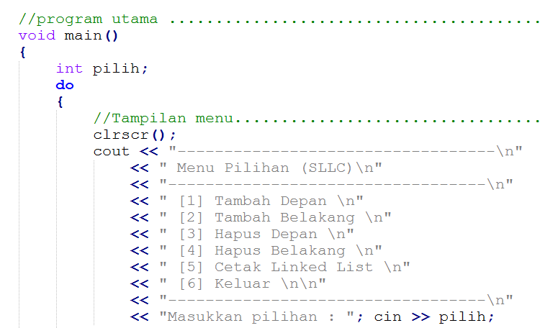

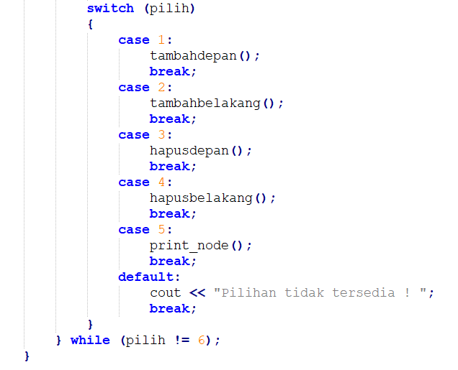

Output program :

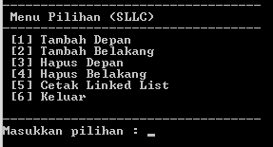

Pilihan [1]
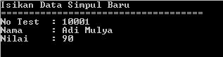

Pilihan [5]
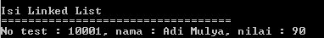

Pilihan [2]
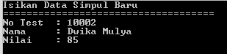

Pilihan [5]
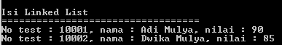

Pilihan [4]
-

Pilihan [5]

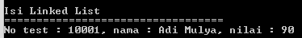

DIKUMPULKAN :
Nama File : A12P99AlproXXXXXNama (99 nomor tugas, XXXXX : 5 digit NIM terakhir)
Format file : PDF
Dikirim ke : suharnawi@dsn.dinus.ac.id
Dikumpulkan paling lambat 20 Desember 2020

Source code :

#include <iostream.h>
#include <conio.h>
#include <stdio.h>

struct Node
{
int notest;
char nama[20];
int nilai;
Node *next;
};

Node *head = NULL;
Node *tail = NULL;

void tambahdepan()
{
Node *temp;
// masukkan data...........................
temp = new Node;
clrscr();
cout << "Isikan Data Simpul Baru\n";
cout << "====================================\n";
cout << "No Test : "; cin >> temp->notest;
cout << "Nama : "; gets(temp->nama);
cout << "Nilai : "; cin >> temp->nilai;
temp->next = temp;
cout << endl;

// Set up link to this node........................
if (head == NULL)
{
head = temp;
tail = temp;
}
else
{
temp->next = head;
head = temp;
tail->next = head;
}
}

void tambahbelakang()
{
Node *temp;
// masukkan data...........................
temp = new Node;
clrscr();
cout << "Isikan Data Simpul Baru\n";
cout << "====================================\n";
cout << "No Test : "; cin >> temp->notest;
cout << "Nama : "; gets(temp->nama);
cout << "Nilai : "; cin >> temp->nilai;
temp->next = temp;
cout << endl;

// Set up link to this node........................
if (head == NULL)
{
head = temp;
tail = temp;
}
else
{
tail->next = temp;
tail = temp;
tail->next = head;
}
}

void hapusdepan()
{
Node *temp;
temp = head;
// cek apakah kosong, 1 node, atau bbrp node.......
if (head == NULL)
{
cout << "\n\nLinked List Kosong ! [Enter] ";
getch();
}
else
{
//jika ada sebuah node.........................
if(head->next == head)
{
head = NULL;
tail = NULL;

}
else
{
//jika node lebih dari 1...................
head = head->next;
tail->next = head;
}
delete temp;
}
}

void hapusbelakang()
{
Node *temp1, *temp2;
temp2 = tail;
// cek apakah kosong, 1 node, atau bbrp node.......
if (head == NULL)
{
cout << "\n\nLinked List Kosong ! [Enter] ";
getch();
}
else
{
//jika ada sebuah node.........................
if(head->next == head)
{
head = NULL;
tail = NULL;

}
else
{
//jika node lebih dari 1...................
temp1 = head;
while(temp1->next != tail)
{
temp1 = temp1->next;
}
tail = temp1;
tail->next = head;
}
delete temp2;
}
}

void print_node()
{
Node *temp;
temp = head;

if(temp == NULL)
cout << "\n\nEmpty List ! [Enter]";
else
{
clrscr();
cout << "\nIsi Linked List\n";
cout << "=========================================\n";
do
{
cout << "No test : " << temp->notest;
cout << ", nama : " << temp->nama;
cout << ", nilai : " << temp->nilai;
cout << endl;
temp = temp->next;
} while(temp != head);
cout << "=========================================\n";
}
getch();
}

//program utama ...........................................
void main()
{
int pilih;
do
{
//Tampilan menu....................................
clrscr();
cout << "----------------------------------\n"
<< " Menu Pilihan (SLLC)\n"
<< "----------------------------------\n"
<< " [1] Tambah Depan \n"
<< " [2] Tambah Belakang \n"
<< " [3] Hapus Depan \n"
<< " [4] Hapus Belakang \n"
<< " [5] Cetak Linked List \n"
<< " [6] Keluar \n\n"
<< "----------------------------------\n"
<< "Masukkan pilihan : "; cin >> pilih;
switch (pilih)
{
case 1:
tambahdepan();
break;
case 2:
tambahbelakang();
break;
case 3:
hapusdepan();
break;
case 4:
hapusbelakang();
break;
case 5:
print_node();
break;
default:
cout << "Pilihan tidak tersedia ! ";
break;
}
} while (pilih != 6);
}

