Topik 5 Queue
Jumat, 30 Oktober 2020

Latihan 1 :
Kode program :

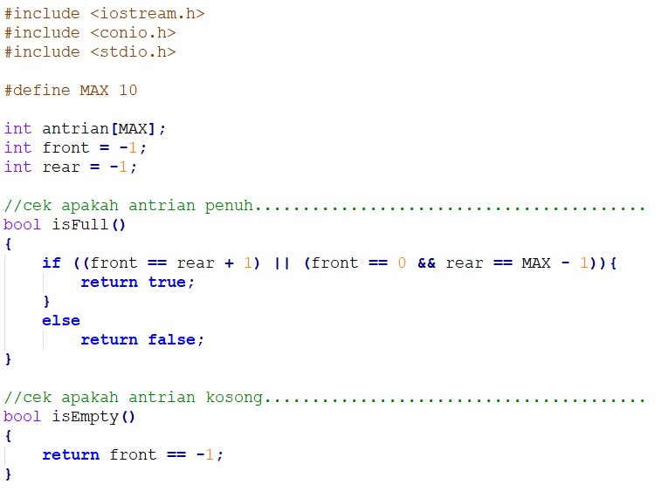
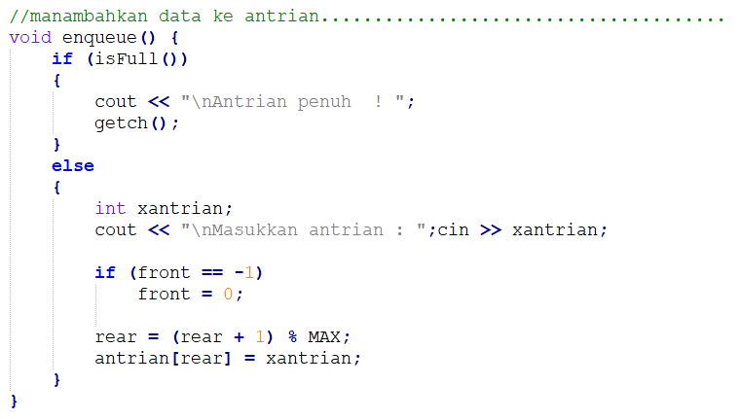
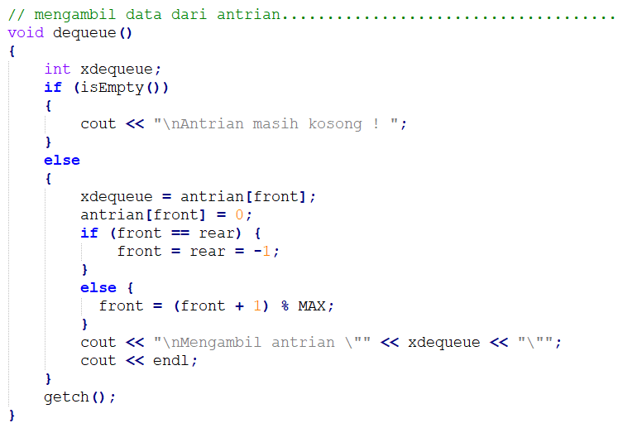
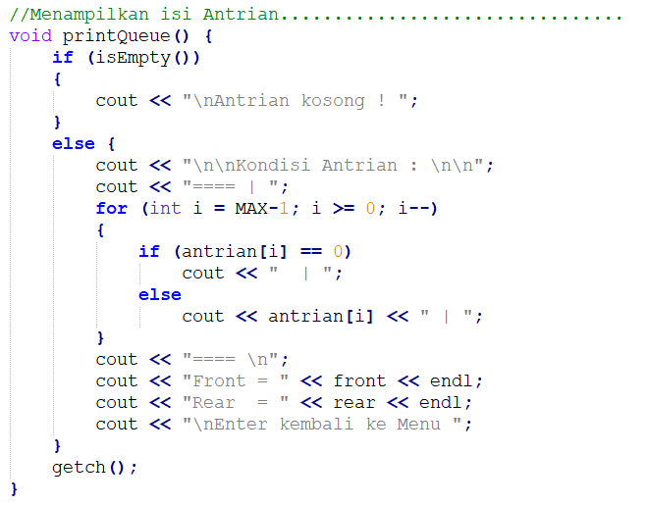
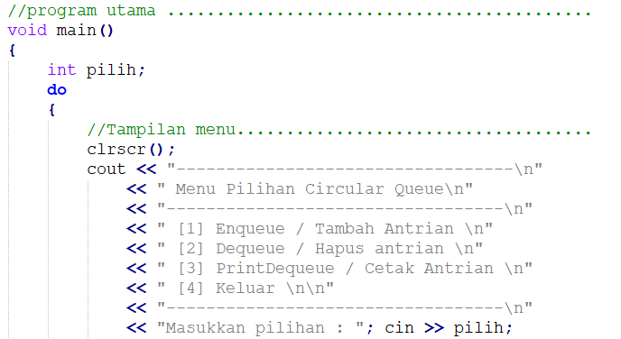
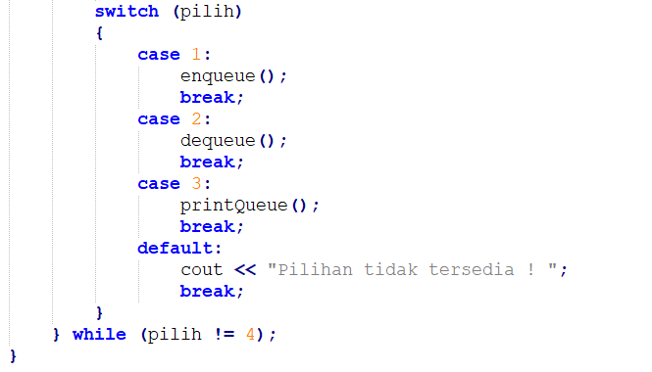

Output program :

- Enqueue / masukkan nilai 8 (pilih 1)

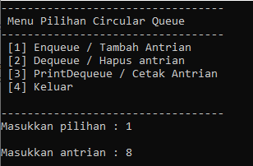

- Cetak Kondisi Antrian (pilih 3)

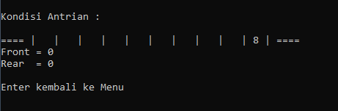
- Dimasukkan nilai 5, 4, dan 9 (pilih 1)
- Cetak Kondisi Antrian (pilih 3)

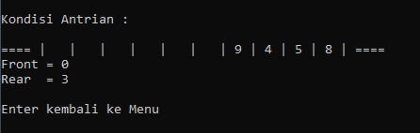

- Dequeue/hapus data Antrian (pilih 2)

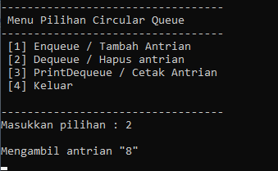

- Cetak Kondisi Antrian (pilih 3)

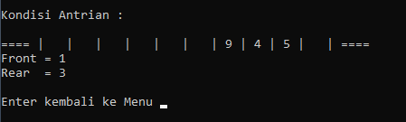

- Dimasukkan nilai 1, 2, 3, 4, 5, 6, dan 7 (pilih 1)
- Cetak Kondisi Antrian (pilih 3)

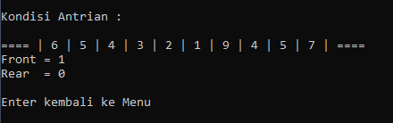
- Dequeue/hapus data Antrian (pilih 2)
- Cetak Kondisi Antrian (pilih 3)

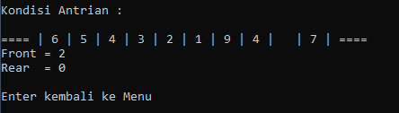

Tugas :
Gambarkan kodisi antrian jika dilakukan proses berikut ini :
- Enqueue 2

- Enqueue 8, 3, 6, dan 9
- dequeue
- Enqueue 7, 5, 2, dan 4
- Dequeue
- Dequeue
- Dequeue
- Enqueue 1, 3, 6, dan 9
- dequeue
- dequeue

DIKUMPULKAN :
Nama File : A12P99AlproXXXXXNama (99 nomor tugas, XXXXX : 5 digit NIM terakhir)
Format file : PDF
Dikirim ke : suharnawi@dsn.dinus.ac.id
Dikumpulkan paling lambat 7 November 2020

Source code program

#include <iostream.h>
#include <conio.h>
#include <stdio.h>

#define MAX 10

int antrian[MAX];
int front = -1;
int rear = -1;

//cek apakah antrian penuh.........................................
bool isFull()
{
if ((front == rear + 1) || (front == 0 && rear == MAX - 1)){
return true;
}
else
return false;
}

//cek apakah antrian kosong........................................
bool isEmpty()
{
return front == -1;
}

//manambahkan data ke antrian......................................
void enqueue() {
if (isFull())
{
cout << "\nAntrian penuh ! ";
getch();
}
else
{
int xantrian;
cout << "\nMasukkan antrian : ";cin >> xantrian;

if (front == -1)
front = 0;

rear = (rear + 1) % MAX;
antrian[rear] = xantrian;
}
}

// mengambil data dari antrian.....................................
void dequeue()
{
int xdequeue;
if (isEmpty())
{
cout << "\nAntrian masih kosong ! ";
}
else
{
xdequeue = antrian[front];
antrian[front] = 0;
if (front == rear) {
front = rear = -1;
}
else {
front = (front + 1) % MAX;
}
cout << "\nMengambil antrian \"" << xdequeue << "\"";
cout << endl;
}
getch();
}

//Menampilkan Queue
void printQueue() {
if (isEmpty())
{
cout << "\nAntrian kosong ! ";
}
else {
cout << "\n\nKondisi Antrian : \n\n";
cout << "==== | ";
for (int i = MAX-1; i >= 0; i--)
{
if (antrian[i] == 0)
cout << " | ";
else
cout << antrian[i] << " | ";
}
cout << "==== \n";
cout << "Front = " << front << endl;
cout << "Rear = " << rear << endl;
cout << "\nEnter kembali ke Menu ";
}
getch();
}

//program utama ...........................................
void main()
{
int pilih;
do
{
//Tampilan menu....................................
clrscr();
cout << "----------------------------------\n"
<< " Menu Pilihan Circular Queue\n"
<< "----------------------------------\n"
<< " [1] Enqueue / Tambah Antrian \n"
<< " [2] Dequeue / Hapus antrian \n"
<< " [3] PrintDequeue / Cetak Antrian \n"
<< " [4] Keluar \n\n"
<< "----------------------------------\n"
<< "Masukkan pilihan : "; cin >> pilih;
switch (pilih)
{
case 1:
enqueue();
break;
case 2:
dequeue();
break;
case 3:
printQueue();
break;
default:
cout << "Pilihan tidak tersedia ! ";
break;
}
} while (pilih != 4);
}

