http://www.nhlbi.nih.gov/health/health-topics/topics/atherosclerosis

What Is Atherosclerosis?
Atherosclerosis (ath-er-o-skler-O-sis) is a disease in which plaque (plak) builds up inside your arteries. Arteries are blood vessels that carry oxygen-rich blood to your heart and other parts of your body.
Plaque is made up of fat, cholesterol, calcium, and other substances found in the blood. Over time, plaque hardens and narrows your arteries. This limits the flow of oxygen-rich blood to your organs and other parts of your body.
Atherosclerosis can lead to serious problems, including heart attack, stroke, or even death.

Atherosclerosis
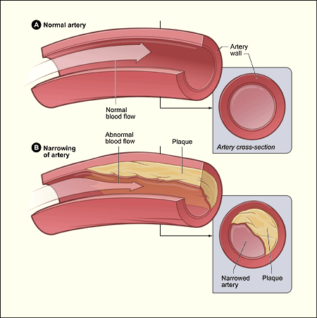
Figure A shows a normal artery with normal blood flow. Figure B shows an artery with plaque buildup.

Atherosclerosis-Related Diseases
Atherosclerosis can affect any artery in the body, including arteries in the heart, brain, arms, legs, pelvis, and kidneys. As a result, different diseases may develop based on which arteries are affected.

Coronary Heart Disease
Coronary heart disease (CHD), also called coronary artery disease, is the #1 killer of both men and women in the United States. CHD occurs if plaque builds up in the coronary arteries. These arteries supply oxygen-rich blood to your heart.
Plaque narrows the coronary arteries and reduces blood flow to your heart muscle. Plaque buildup also makes it more likely that blood clots will form in your arteries. Blood clots can partially or completely block blood flow.
If blood flow to your heart muscle is reduced or blocked, you may have angina (chest pain or discomfort) or a heart attack.
Plaque also can form in the heart's smallest arteries. This disease is called coronary microvascular disease (MVD). In coronary MVD, plaque doesn't cause blockages in the arteries as it does in CHD.

Carotid Artery Disease
Carotid (ka-ROT-id) artery disease occurs if plaque builds up in the arteries on each side of your neck (the carotid arteries). These arteries supply oxygen-rich blood to your brain. If blood flow to your brain is reduced or blocked, you may have a stroke.

Peripheral Arterial Disease
Peripheral arterial disease (P.A.D.) occurs if plaque builds up in the major arteries that supply oxygen-rich blood to your legs, arms, and pelvis.
If blood flow to these parts of your body is reduced or blocked, you may have numbness, pain, and, sometimes, dangerous infections.

Chronic Kidney Disease
Chronic kidney disease can occur if plaque builds up in the renal arteries. These arteries supply oxygen-rich blood to your kidneys.
Over time, chronic kidney disease causes a slow loss of kidney function. The main function of the kidneys is to remove waste and extra water from the body.

Overview
The cause of atherosclerosis isn't known. However, certain traits, conditions, or habits may raise your risk for the disease. These conditions are known as risk factors.
You can control some risk factors, such as lack of physical activity, smoking, and an unhealthy diet. Others you can't control, such as age and a family history of heart disease.
Some people who have atherosclerosis have no signs or symptoms. They may not be diagnosed until after a heart attack or stroke.
The main treatment for atherosclerosis is lifestyle changes. You also may need medicines and medical procedures. These treatments, along with ongoing medical care, can help you live a healthier life.

Outlook
Improved treatments have reduced the number of deaths from atherosclerosis-related diseases. These treatments also have improved the quality of life for people who have these diseases. However, atherosclerosis remains a common health problem.
You may be able to prevent or delay atherosclerosis and the diseases it can cause. Making lifestyle changes and getting ongoing care can help you avoid the problems of atherosclerosis and live a long, healthy life

http://www.nhs.uk/conditions/atherosclerosis/Pages/Introduction.aspx
Atherosclerosis is a potentially serious condition where arteries become clogged up by fatty substances known as plaques or atheroma.
The plaques cause affected arteries to harden and narrow, which can be dangerous as restricted blood flow can damage organs and stop them functioning properly.
If a plaque ruptures, it can cause a blood clot. This can block the blood supply to the heart, triggering a heart attack, or it can block the blood supply to the brain, triggering a stroke.

Cardiovascular disease (CVD)
Atherosclerosis is a major risk factor for many conditions involving the flow of blood.
Collectively, these conditions are known as cardiovascular disease (CVD). Examples include:
- peripheral arterial disease – where the blood supply to your legs is blocked, causing muscle pain
- coronary heart disease – the coronary arteries (the main arteries that supply your heart) become clogged with plaques
- stroke – where the blood supply to your brain is interrupted
- heart attack – where the blood supply to your heart is blocked
Read more about atherosclerosis and cardiovascular disease.

What causes atherosclerosis?
Exactly how arteries become clogged is still unclear, although the following things increase your risk of atherosclerosis:
- smoking
- a high-fat diet
- lack of exercise
- being overweight or obese
- having either type 1 or type 2 diabetes
- having high blood pressure (hypertension)
- having high cholesterol
Read more about causes and risk factors for atherosclerosis.

Treating atherosclerosis
Treatment for atherosclerosis aims to prevent the condition from worsening to the point that it can trigger a serious cardiovascular disease, such as a heart attack.
This can be achieved by making lifestyle changes, such as eating a healthier diet and increasing exercise, as well as using certain medications such as ACE inhibitors to treat high blood pressure, or statins to lower cholesterol levels.
In some cases, surgery may be required to widen or bypass a section of a blocked or narrowed artery.
Read more about the treatment of atherosclerosis.

Who is affected?
It is hard to estimate how common atherosclerosis is, although it is suspected that almost all adults have the condition to some degree.
Your arteries naturally get harder as you grow older, so atherosclerosis tends to be more common in people aged over 40.
Atherosclerosis is more common in men than women, possibly because hormones used in the female reproductive cycle, such as oestrogen, provide some protection against the effects of the condition.

The public health impact of atherosclerosis
Atherosclerosis (and the resulting cardiovascular diseases) is the single biggest cause of death in the developed world, accounting for one in three of all deaths.
Each year an estimated 124,000 deaths are caused by cardiovascular disease in England and Wales. Around 39,000 of these deaths occur in people under 75 years.
For every death, cardiovascular disease causes two non-fatal but serious complications, such as a stroke or heart attack.
It is expected that atherosclerosis will continue to be a major health problem in this country because of the ongoing obesity epidemic.

